BRIDGING THE AMERICAN DIVIDE (B8585)
BIDDING SYLLABUS
FALL A & B TERM
Uris 329, Tuesdays, 2:15pm – 5:30pm
Professor : | Bruce Usher
Office : | Uris 316a (office hours by appointment)
E-mail : | bmu2001@gsb.columbia.edu
Voice : | 212.854.7631

PURPOSE
Americans are a deeply divided people. The purpose of this course is to help interested Columbia Business School students gain a better understanding of the causes and consequences of the American divide—and what they might do to help bridge it.
METHOD
There will be (7) three-hour classroom sessions in Uris 329 on Tuesdays from 2:15pm - 5:30pm
(Sept 11 / Sept 18 / Sept 25 / Oct 2 / Oct 9 / Oct 30 / Nov 13) and a four-day field trip to Youngstown, Ohio from 2 - 6 November 2018.

Class sessions will be devoted to topics exploring the causes and consequences of a divided America. These will be followed by a four-day visit to Youngstown, Ohio where students will be engaged in a variety of learning activities. These will include social settings as well as meetings with individuals associated with organizations whose fortunes have been changed by de-industrialization—manufacturers, unions, local government, and nonprofit service-providers. In addition, students will write a paper, not to exceed 10 pages in length, on a topic worked out with the instructors.
REQUIREMENTS
Students must apply for one of the limited number of seats in the course. As becomes a select group, students are expected to be prepared for and participate thoughtfully in all aspects of the course, including the seven class sessions at CBS and site visits in Youngstown.

COURSE OVERVIEW AND SCHEDULE:

Class 1 | Sept 11, 2018 | Introduction to the Course and Causes of the Great Divide
Topics: Expectations for the course, student and instructor introduction, general introduction to the Great Divide, how to talk about it, and the causes.

Readings and Study Questions:
Topic A (Profs Jick & Usher): General Introduction to the “Divide” and How We Talk About It
- “The Problem Isn’t How We Feel About Trump-- It’s How We Feel About Each Other” Diane Hessan, Boston Globe, July 19, 2018.
- “Liberal Blind Spots are Hiding the Truth About “Trump Country”, Sarah Smarsh, NY Times, July 18, 2018
- “Leaders Can’t Shy Away from Sensitive Topics” Bill Boulding, HBR, March 13, 2018
Study Questions:
  - What are the key messages of these “Opinion” articles?
  - What do you most agree with? Disagree with? Why?
  - What should we heed from these articles in the way we will conduct our classes in Bridging the American Divide?
Topic B (Prof Ray Horton): Causes of the Great Divide
- "You Can't Separate Money from Culture" Andrew J. Cherlin, New York Times, May 6, 2018.
- Richard Reeves, Dream Hoarders (Washington, D.C.: The Brookings Institution, 2017), Chs.1-2.

Class 2 | 18 Sept 2018 | Globalization (Cause) and Political Tribes (Consequence)
Topics: Effects of competition from abroad, trade imbalances, the outsourcing of employment, and the rise of “political tribes” in America.
Readings and Study Questions:
Topic A (Prof Usher): Globalization
- “The Economic Gains from Trade: Comparative Advantage” (HBS 796-183)
- “Importing Political Polarization? The Electoral Consequences of Rising Trade Exposure” (Autor et al) –pages 1-6 and conclusion
Study Questions:
- Why do economists believe more trade is always beneficial to a country?
- In what situations might more trade be harmful?
- What is the relationship between trade and political polarization?

Topic B (Prof Jick): “Political Tribes”
- Excerpts from Political Tribes, Amy Chua, Penguin and Random House, 2018, Introduction, pp. 1-11 and Chapter 8, pp.177-196 (“Identity Politics”)
- “CASE”: NY Times Video Documentary, “Inside a Steel Plant Facing Layoffs” 2018 (in library course reserves and online) (14 minutes)
- “The Retreat to Tribalism” David Brooks, NY Times, Jan 2, 2018
- (Optional) "Iowa's Next Election - Bridging the Urban-Rural and Class Divide," Christopher Martin, Working Class Perspectives, July 9, 2018.
- (Optional) “College Faculty Member Caught on Video Telling Asian Americans to ‘Go Back to Their Home Country’” Carol Kuravilla, Huffington Post, March 9, 2018.
Study Questions:
- In the NYT video, Steelworkers were incented to “train their replacements” from the Mexican factory: 1) Why did Mark and John each react the way they did?, 2) How would you have reacted if you were in their shoes?, 3) How would you view “globalization” from their standpoint?, and 4) How do you react to the Union protest that “American Workers Are Under Attack”?
- What did you learn about “political tribes” from the Chua chapters and Brooks article? Do you agree with the “new tribal left” and the “new tribal right” framework?

Class 3 |  | Technology, Automation, AI (Causes) and Job Loss and Skill Impacts (Consequences)
Topics: The longstanding debate over the relationship between technological innovation and the demand for labor, the potential impact of machine learning and robotics on employment in the US, and the impact of job loss on American communities.
Readings and Study Questions:
Topic A (Prof Usher): Technology, Automation and AI
- Why Trump Doesn’t Tweet about Automation, Tom Davenport, HBR, Jan 12, 2017.
- David Autor and Anna Salomons, “Does Productivity Growth Threaten Employment?” MIT Working Paper, June 2017; read pages 1 to top of 7, and conclusion pages 46-47.
Study Questions
- Why do politicians rarely talk about automation? Should they?
- Will rising automation in the US lead to lower employment and/or lower wages?

Topic B (Prof Jick): Job Loss Impacts / Skills
- “Why Do Americans Stay When Their Town Has No Future?”Alex MacGillis, Bloomberg Business Week, May 23, 2018.
- “Safeway Buyout: Take a Trip Down Memory Lane,” Tom Gara, WSJ, March 5, 2014
- “A Conversation About LBO’s: A Second Year HBS Student” from Managing Change, 1st edition, Todd Jick, pp.304-308.
- (optional) “When good jobs disappear quietly: Comparing yesterday's printers to today's coal-miners,” Jay Urwitz, NY Daily News, 23 July 2018.
Study Questions
- After reading MacGillis article, what would you recommend they do—stay or leave their community? Why?
- After reading the Safeway buyout article, how would you characterize the broad impact of job loss potentially on individuals, families, communities and society?
- What is your personal opinion on the issues raised by the 2nd year HBS student about our business system? In other words, would you feel his same ambivalence? Why or why not?

Class 4 | 2 Oct 2018 | Legal and Illegal Immigration; Race Relations
Topics: a) Effects of immigration from abroad and migration within; winners and losers from changes in the American labor pool, and reaction from community groups; b) Race relations divide and socio economic impacts.
Readings and Study Questions:
Topic A (Prof Usher): Legal and Illegal Immigration
- George Borjas, “Immigration and the American Worker: A Review of the Academic Literature”, Center for Immigration Studies, April 2013; - read pages 1-3 and 17-19.
- National Academies of Sciences, Engineering, and Medicine Press Release, “Immigration's Long-Term Impacts on Overall Wages and Employment of Native-Born U.S. Workers…” September 21, 2016.
- (Optional) “Ohio’s Super Smart Immigrants” OZY, May 8, 2018
Study Questions:
- Do immigrants to the US reduce employment and/or wages of native born workers?
- Which Americans are most likely to benefit from immigration? Which are most likely to be hurt by immigration?

Topic B (Prof Jick): Race Relations (Guest Speaker: Professor Van Tran, Sociology, Columbia University—expert in race, ethnicity and immigration)
- Excerpts from So You Want to Talk About Race Ijeoma Oluo, Hachette Books, (2018), Introduction (pp. 1-7), Chapters One (pp. 8-22), Eight (pp. 121-133) and Fourteen (pp. 189-200); OR see YouTube video , “So You Want to Talk About Race” (Google Talks, Feb 6, 2018) (:51)
- “Stop Pretending Black Midwesterners Don’t Exist” Tamara Winfrey Harris, NY Times, June 17, 2018
- “Too Many Americans Think Patriotism Means Racism and Xenophobia” Susan Raghunathan, The Nation, Sept 11, 2017.
- (Optional) “It’s Not just Starbucks: White Fear is an American Problem” Renee Graham, Boston Globe, April 16, 2018
Study Questions
- What are the key manifestations and causes of racial and ethnic divides in America?
- In Oluo’s Chapter One, she asks, “Is It Really About Race”? What do you think? In Chapter 14, she discussed “The model minority myth” and its impact on Asian Americans—what do you think?
- In your experience, are these issues improving, worsening, or staying about the same?

Class 5 | 9 Oct 2018 | Opioids Crisis / Systemic Problems, Systemic Solutions
Topics: a) The Opioid crisis is deepening dramatically and affecting all communities in America. Why has this happened? What is the impact socio-economically on communities and the nation? What are the potential ways to intervene, and what will they cost? b) The multitude of causes and consequences of the Divide in America can be argued to be “systemic” problems requiring systemic solutions—deeper interconnected causes requiring deeper integrated solutions. We will explore systemic explanations of the American Divides and potential systemic solutions.

Readings and Study Questions:
- Guest Speaker: Catherine Paquette, M.P.S, Department of Psychology and Neuroscience, University of North Carolina
Topic A (Prof Jick) : Opioids Crisis
- “The Poison We Pick”, Andrew Sullivan, New York Magazine, 20 February 2018.
- “Ten Insights on the US Opioid Crisis from Claims Data Analysis” Sarun Charumillind, Elena Mendez-Escobar, and Tom Latkovic, McKinsey Quarterly, June 2018.
- “How a Police Chief, a Governor and a Sociologist Would Spend $100 Billion to Solve the Opioid Crisis” Josh Katz, NY Times, Feb 14, 2018.
- (optional) Heroin(e) (film; available on Netflix; 39min)
Study Questions
- Why has the Opioid crisis emerged and deepened?
- What are the consequences socio-economically—on individuals, communities, societally, and financially?
- Are the impacts and solutions distributed “equally”?

Topic B (Profs Jick and Usher): Systemic Problems, Systemic Solutions
- “The Birth of a New Aristocracy” Matthew Stewart, Atlantic, June 2018. (Long but rich article; give it at least a good skim!)
- "The State of the Working Class" Interview with Dr. Sherry Linkon, 2017 (audio)
- “Lessons from Rust-Belt Cities that Kept Their Sheen” Eduardo Porter, NY Times, May 1, 2018.
- “The Real Villain Behind Our New Gilded Age” Eric Posner and Glen Weyl, NY Times, May 1, 2018
- “Think Positive, Climb Out of Poverty? It Just Might Work” Seema Jayachandran, NY Times, July 15, 2018.
Study Questions:
- Stewart offers a comprehensive analysis of the American “system” called “a new aristocracy”. In what ways do you agree with him and in what ways do you disagree?
- Linkon’s podcast offers insights into the “system” and world of the American working class, drawing on her work from Youngstown. What insights did you gain from her analysis and observations?
- What do these analyses and the other readings lead us to consider as “systemic solutions”?

Class 6 | 30 Oct 2018 | Learning to Dialogue and Preparing for Youngstown
Topics: a) How well do companies dialogue and interface with sensitive political and social issues? How will we as a class interact with each other and with those we meet in Youngstown around issues that we may find contrary to our own values and experiences? B) What are the key background factors and information about Youngstown we need to know prior to our visit -- the history, demographics, economics, and politics of Youngstown and surrounding suburbs?

Readings and Study Questions:
Topic A (Prof Jick): Learning to Dialogue
- Case: “The Battle of Ideas and Ideologies at Google: The Engineers Manifesto about Diversity and the Dialogue,” to be distributed prior to the class.
- “Google vs. Google: How Non-stop Political Arguments Rule Its Workplace,” Doug McGregor, WSJ, May 1, 2018.
Study Questions
- Why was the Damore “incident” so significant for Google?
- How well was it handled by the company? What has happened since that time at Google to enable people to discuss their key passions and concerns? Do you think it is effective?
- How do you recommend companies engage in discourse about sensitive political and social issues?
- How should we prepare ourselves for constructive discourse in Youngstown among ourselves and with the people we will be meeting?

Topic B (Katie Spradley): Preparing for Youngstown
- “Trump, Tariff, and a Glint of Hope Flickers in ‘Steeltown USA’” Patti Waldmeir, Financial Times, March 14, 2018.
- “Two Tomorrows”: Economic and Community Strategy for the Region, 2017 Report.
- Podcast: “The Rust Belt Resurgence: Who Really Benefits?” May 21, 2018, City Club of the Mahoning Valley
- Steel Town 1944; 16:05 min; available by internet/YouTube
- A Dream of Youngstown
  - Part 1; 7:08 min; available by internet/YouTube
  - Part 2; 7:56 min; available by internet/YouTube
Study Questions
- What are the most intriguing learnings for you from the Youngstown prep readings?
- What questions are raised for you based on the readings that you hope to have answered during our Youngstown visit?

Class 7 thru 11 | 2 – 6 Nov 2018 | Trip to Youngstown, Ohio
Details will be provided separately.

Class 12 | 13 Nov 2018 | Wrap Up of the Course: Lessons Learned, Applications to You
Topics: Takeaways from the Youngstown Visit—what insights did you gain from the Youngstown visit? What are the business and economic themes that must be understood? What aspects of the Divide in America are better understood now? What are the potential avenues for individuals, communities, and American society/politics to help “bridge the divide”? What public policies must play a role in all this? What do you see as your own role and your own responsibility as a future business leader in regard to the Divide and the path forward?

Readings and Study Questions:
- “Our Newest Cultural Warriors: Activist CEO’s,” Aaron Chatterji, NY Times, March 5, 2018
- “Silicon Valley is Over, Says Silicon Valley” Kevin Roose, NY Times, March 5, 2018
- (Optional) “Trump’s Populism: What Business Leaders Need to Understand,” Rafael Di Tella, HBS Cold Call Podcast transcript, March 22, 2018.
Study Questions
- What are your key takeaways from the Youngstown visit?
- What questions remain in your mind?
- In what ways are you hopeful for the future of Youngstown? Less hopeful?
- What insights have you gained about the “Divide” in America?
- What can and should companies do (e.g. Activist CEO’s) about the many issues represented in what we saw in Youngstown?

GRADING:
Contribution to the learning process and the paper will be weighted equally in determining the final grade.

- Class and Trip Participation (50%): Includes engagement and contributions made in class discussions, with course guests, during the Youngstown trip, debriefs, and other discussions. We will also use “YellowDig” (described below), an interactive online platform allowing us to continue to discuss and deepen our knowledge between classes.
- Final Paper (50%): Specific questions will be set out for the paper due on Monday, December 3, 2018.

Yellow Dig

YellowDig is an interactive online platform which allows us to continue learning and conversing “off line” from our class meetings. Its purpose is to provide commentary, relevant articles, videos, debates, etc. beyond what we have time to do in class.

Your ticket to admission to the website is to CONTRIBUTE-- an article, a blog, an update, a link, a stimulating question, a stimulating response. These will be in the form of a POST, a COMMENT, and LIKES. We would expect that each student can add value in some way, and in so doing, gain a tremendous amount from others who are adding value. The more you give, the more you will gain! We would hope to see at least 2 contributions per student and at least 2 “comments” on other’s contributions, as well as “likes”. There is a scoring system where you are expected to reach 100 points minimum.

Here’s what to do:
    - Give your contribution a title which will inform and entice the reader
    - Provide an intro paragraph to what the article or commentary is all about, and what interesting issue or question it addresses.

You will access YellowDig by clicking the tab on the left-hand side of the Canvas course. Do NOT access through Web as you will not be in Class list that way—ONLY USE CANVAS. Please add your PHOTO to your registration on Canvas.

YellowDig will function as a component of your Class Participation score. Each student will be expected to make at least two “Pins” and two “Comments” over the course of the semester, and you will see that is roughly 100 points….

Note: A pin requires an introductory paragraph—of at least 25 words, explaining the nature and importance of your contribution. At least 25 words is required per Pin or Comment to receive points.

An Important Tip: Be careful when linking to sites or articles that require logins! Make sure to make use of the “Preview” feature to make sure YellowDig can display your Pin effectively. Articles from websites like the New York Times, Wall Street Journal, the Financial Times, etc., will require logins- submitting these traditionally may create a barrier for your classmates. Instead, you should make a PDF of the article you wish to share, which you can attach to your Pin.
How To Begin: Make a Pin!
- First, press the pin button at the top left.
- Then, copy and paste the link and an image and short summary of the article should appear.
- Write down your thoughts on the article (where appropriate add pictures, videos, or documents, and tag information) and press post.
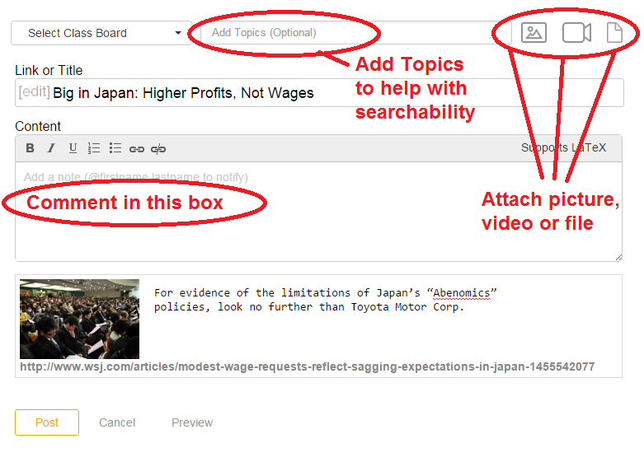
You can also tag people in your post by typing @their name in your pin.
You may be using YellowDig in other courses. You will be able to cycle through your course “boards” using the dropdown at the top of the page:
YellowDig will send you e-mail notifications, based on your Notifications Settings. Note: These are independent of your CANVAS Notifications Preferences.
You can adjust your YellowDig Notifications Preferences by first your name and dropdown menu from the upper-right:
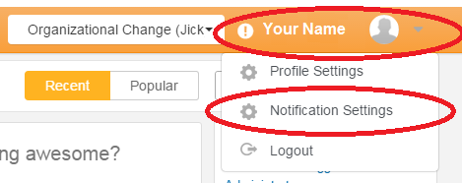
Then, choose the items when you want to get notified, and click UPDATE:
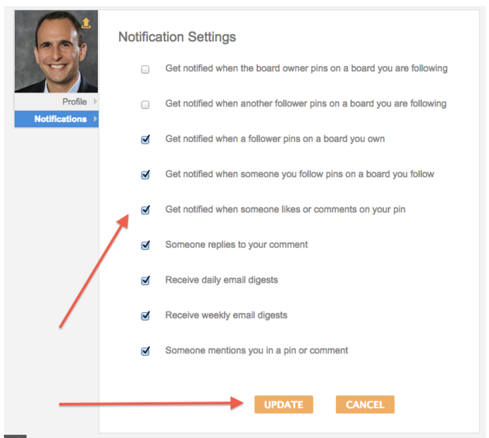

- If you encounter any issues you should contact the CBS Canvas Team at canvas@gsb.columbia.edu

