Digital Literacy for Decision Makers
Spring (B) Semester, 2021

Instructor: Brett Martin
Course #: B8125, sec. 1
E-mail: blm2150@gsb.columbia.edu
Class Hours: -
Teaching Assistant: -
Office Hours: 15 minute slots in the hour leading into class. Contact your TA to schedule.

COURSE DESCRIPTION
Unrelenting technological progress demands entrepreneurs, executives, and managers to continually upgrade their skills in the pursuit of emerging opportunities. As “software eats the world”, executives from all industries are increasingly called upon to be “Full Stack”: capable of making competent decisions across domains as diverse as digital technology, design, product, and marketing.

In this course, we begin with primers on code, design, and product management. Once the foundation is laid, we examine the best practices for building great products and exceptional teams. We conclude with an overview of how technology is changing the way products are marketed, distributed, and monetized. Our goal is to equip “non-technical” executives with the terminology, tools, and context required to effect change in a software­ and internet-driven world.

INSTRUCTOR
Brett Martin is a Brooklyn-based entrepreneur and investor. He is the managing director of Charge Ventures, an early-stage venture capital fund. Previously, he co-founded @GetSwitch, the easiest way for passive job seekers to find their next job on their mobile phones, and @Sonar, a popular location-based mobile app that leveraged social networks to connect millions of people in the physical world. Before that, Brett built K2 Media Labs, a New York-based seed stage mobile incubator, launched Vice Magazine’s web presence (VBS.tv), and worked on Wall Street as a senior equity research associate at Thomas Weisel Partners. He graduated from Dartmouth College with an A.B. in Economics.

COURSE LEARNING OBJECTIVES
- To understand how technological “sausage is made”
- To make sense of the daily torrent of technology news
- To participate in the digital conversation

In other words...
- To create and build an online brand
- To provide an understanding of the technologies that we encounter every day, and how history can inform the technology decisions executives face today.
- To become familiar with the concepts that underpin modern computer programming, empowering managers to engage with engineers credibly and confidently.
- To shed light on the processes and tools designers use to solve user-facing design and architecture challenges.
- To clarify what product managers do, walk through the nitty-gritty of managing software development, and equip executives with the best practices for evaluating and improving their products.
- To prepare managers to identify, recruit, and nurture the technical talent they will need to succeed in today’s highly competitive labor market.
- To gain awareness of the next generation of technological breakthroughs and understand how those new technologies will share the future business environment

TARGET AUDIENCE
While targeted at non-technical founders, executives, and managers who see the competitive advantage of being able to manage and build digital solutions for their problems, this course is recommended for everyone who agrees that digital literacy is a prerequisite for competition in the 21st century.

COURSE ROADMAP
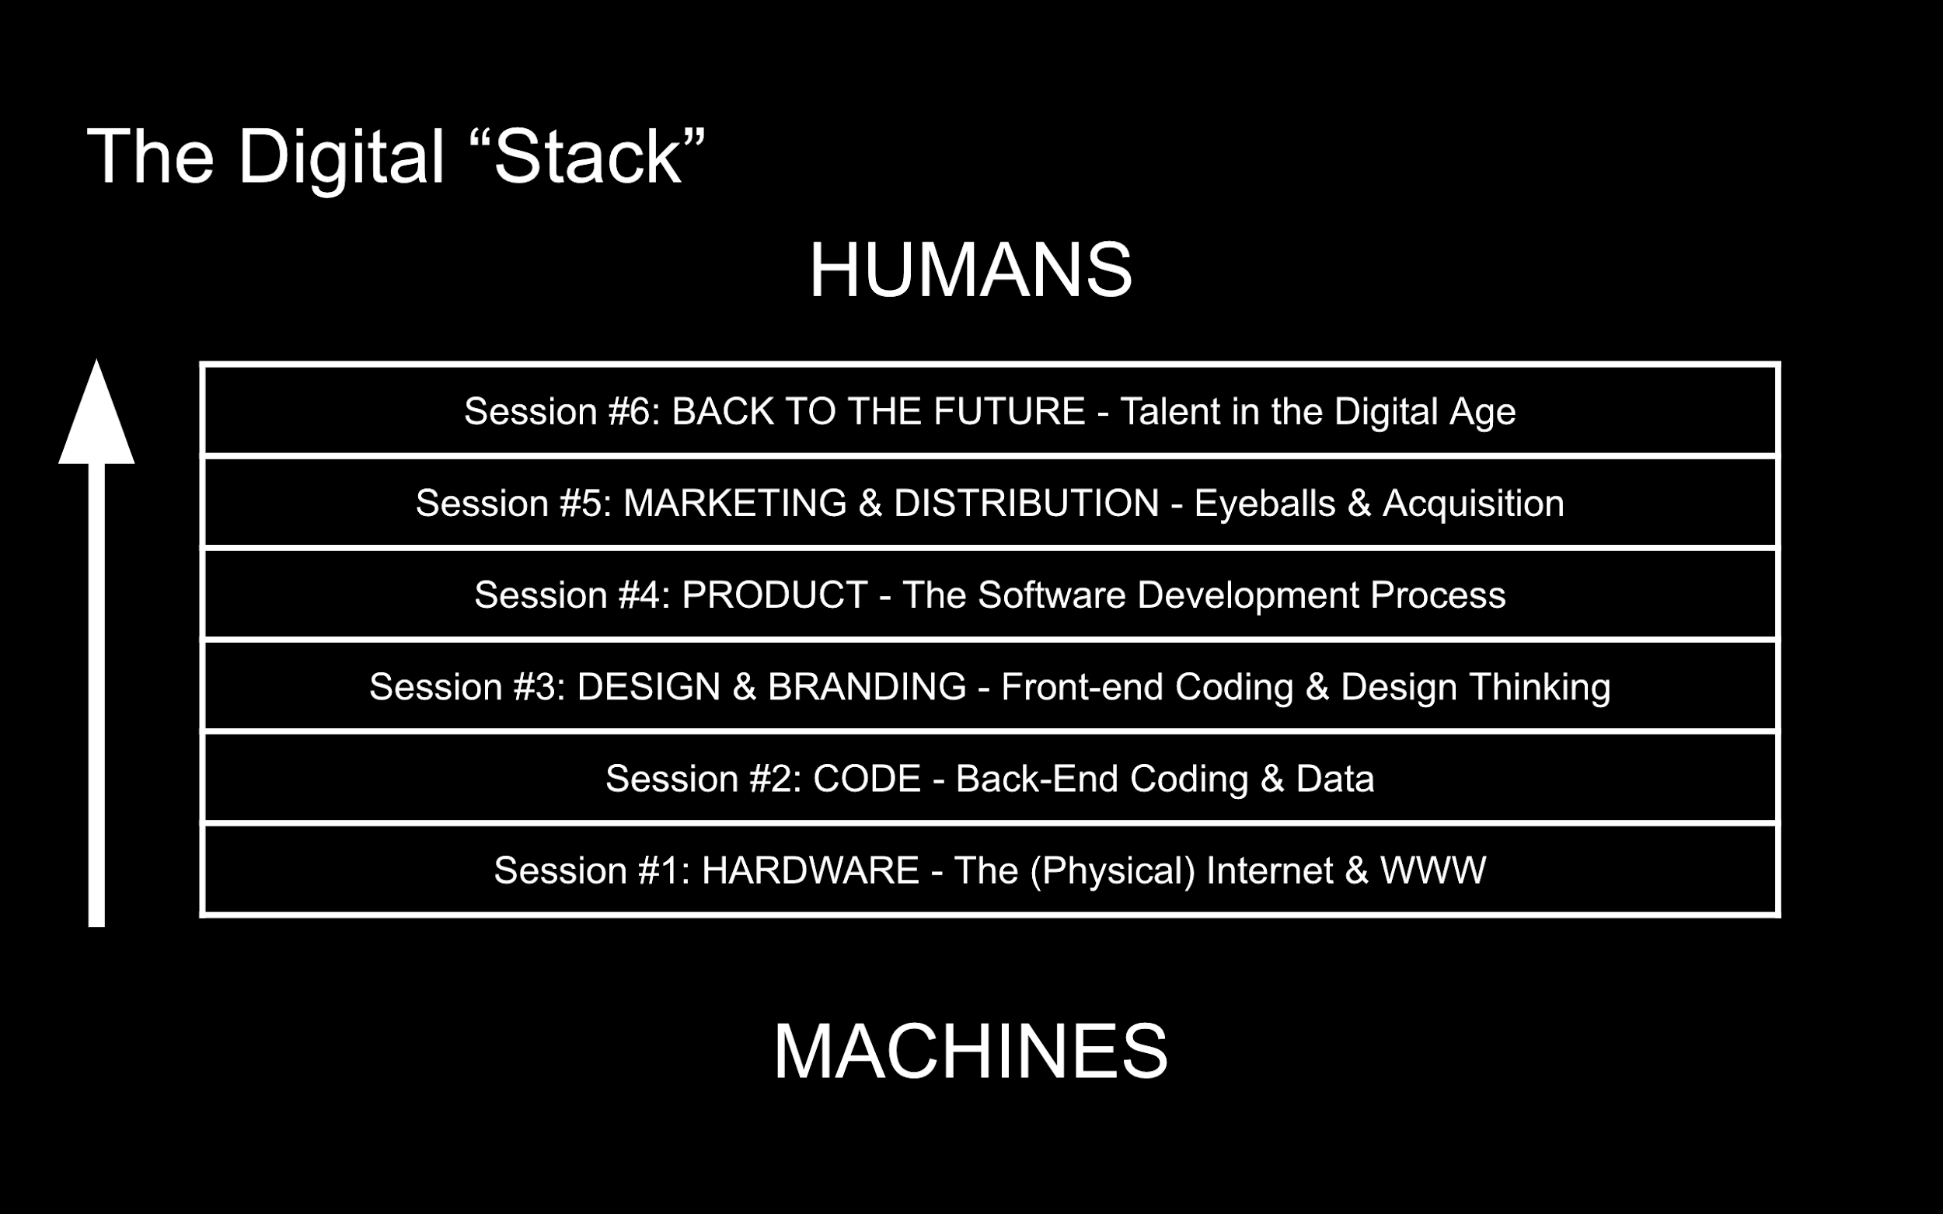
Session 1. HARDWARE: Predicting Technology’s Future by Understanding Its Past
Session one introduces digital literacy by demystifying the technologies we rely on every day. We begin with a rapid-fire history of the Internet, the WWW, and the underlying technologies (ARPAnet, TCP/IP, routers, HTML, web browsers, servers) to illustrate how often abstruse concepts can be understood through a historical lens. For there, we jump right into today’s most pressing but commonly misunderstood issues (The Cloud, Net Neutrality, Privacy & Government Surveillance, Security & Encryption, APIs, The Internet of Things).
Session 2. CODE: Characteristics of Code, the Tech “Stack,” and Back-end Programming
Session two lays out the core characteristics of modern computer programming, answering simple questions such as what is code, what does it look like, and how does it work. Next, we use real-life examples to explore the “tech stack,” helping students decide which coding languages (Java or JavaScript) and databases (SQL or no-SQL) to employ for their own projects. We conclude with an overview of Big Data, Data Science, AI, and other bleeding edge trends to help students decipher between value-add and vaporware.
Session 3. DESIGN & BRAND: Front-end Programming, UI/UX, and Practical Design Concepts
Session three moves up the stack to the interface layer where code and humans interact. We begin with a primer on design thinking, the process designers use to fuse form, function, and content. Once we get our hands dirty learning how to prototype and wireframe, we examine the front-end technologies (HTML, CSS, Javascript) capable of breathing life into our designs. We conclude with an overview of trends in Human-Computer interaction, from desktop to mobile and beyond (VR/AR, IoT, Wearables, and more).
Session 4. PRODUCT: Managing Teams to Make Software that People Want
Session four dives into the dark art of product management: what it is, why it matters, best practices, and common pitfalls. We then examine common engineering patterns (continuous delivery, agile vs. waterfall, testing), agile software development and SCRUM (key principles, roles, and meetings), and techniques for managing technical complexity (CRUD, dependencies, novelties, platforms). We use real-life examples to provide practical tips for writing effective engineering specs (user stories and roadmaps), managing tech teams (features, bugs, code review, chat, git), and addressing common issues in software development (1st Party vs. 3rd Party software, cloud or on-premise, technical debt, scalability). Finally, we equip students with an analytical tool kit for evaluating and improving their existing products (analytics, feature adoption/frequency), as well as a checklist for testing and launching new ones.
Session 5. DIGITAL MARKETING & DISTRIBUTION: Eyeballs & Acquisition
Session five clarifies lingering questions and puts our newfound understanding of technology into context. We explore how digital products are distributed from websites to Facebook to SnapChat to whatever media come next. This session describes the language (SEO, SEM, ASO, CPM, CPC, CPI, CAC, LTV, etc.) used to describe market opportunities (top-down, bottom-up), go to market plans (segmentation, customization, channel selection), and monetization strategies (SaaS, subscription, marketplaces, advertising, lead gen, data) in the digital age.
Session 6. BACK TO THE FUTURE: Humanity and Technology
Session six returns to the human side of the digital revolution. What is the market for digital talent? Do you really need a technical cofounder? If so, where do you find her and how do you convince her to join your team? What is that going to cost?

CLASS CULTURE

- Please come to class prepared and ready to participate actively. The success of this class depends on everyone’s gracious sharing of their perspective, opinion, and experience. I will prod, poke, and instigate debate with questions based on the readings, assignments, current events and/or in-class discussion.
- Be brave. You stand to lose more by towing the line than by genuinely putting yourself out there, as long as you think before you speak. This is also an invitation to let me know if there’s something about the class that is not working for you.
- Be courteous. Please be respectful and professional toward your fellow classmates. I wholeheartedly encourage vigorous debate but please don’t be nasty, aggressive, or condescending. If you feel uncomfortable in class for ANY reason (the material, other students, me, you, anything), please feel free to confidentially email me or the TA. I will do everything I can to make our class hospitable but I can only do so if I am aware of the situation.
- Class will start on time. Show up five minutes early for the good (zoom) seats.

HOMEWORK OVERVIEW
The following homework assignments are designed to maximize student comprehension of course material and help students construct their professional brand online.
Participation (20%) – this class works best when students actively participate. Participation will be measured across three buckets:
- Attendance: we’ll be downloading the attendance from zoom.
  - If you are unable to sign into zoom live during class due to your current geography, you must let us know BEFORE class (email your TA).
  - Students who do not view the class live must watch the recording within 24 hours of posting in order to be considered as having attended.
- Digital Brand Building via posting on Twitter and/or LinkedIn: to encourage class participation and individual professional brand building, each student will be required to actively use Twitter and/or LinkedIn during this course. We require that students post to LinkedIn and/or Twitter at least once a week by 12pm on the Saturday before class and use the hashtag #CBSDigitalLiteracy in your post. Posts should be about class related topics (they will be discussed in the following class). Tweeting or posting on LinkedIn more than once a week will be extra credit, although this is a quality vs. quantity game. Excessive and superfluous posting, just like the real world, will be judged negatively!
  - Note: Students concerned about privacy are more than welcome to create a pseudonymous twitter account.
Submit weekly posts here.

Two Blog / Op-Ed Posts on Medium + comments on your peers’ essays (50%) – students will be asked to write two op-ed / blog post style writings on a technology or ‘digital literacy’ topic of their choosing. See here for sample postings (~800 words). All blog posts will be posted on Medium to our course publication. The topic selection can be broad but should be inspired by recent news and course discussions. The highest graded posts for each submission round will be submitted to Forbes for publishing consideration.
Writings will be graded on the following criteria:
  - 1) well crafted argument, i.e. did you make a statement and back it up with convincing logical reasoning?
  - 2) well researched paper, i.e. did you backup your argument by citing or linking to other sources?
  - 3) well written, i.e. did you proofread, use grammar and vocabulary effectively?
  - 4) subject relevancy, i.e. is the paper topic related to class?
Please 1) publish your post to our Medium publication, 2) tweet or LinkedIn publish your finished Medium posts (with our class hashtag), and 3) share your post to our google form (Medium post #1 form, Medium post #2 form).
Your feedback on your peers’ essays (10%): Students will be asked to provide medium “responses” on 5 of their peers' essays. Those responses will be graded based on the following criteria:
  - 1) Did you add to the conversation with insight, a thoughtful question, or additional data?
Please share a link to your medium responses to our google form (Responses to Medium post #1 form, Responses to Medium post #2 form).
Interview a Developer (20%) – a “Developer” is someone who has written code professionally (i.e. for income). This developer can be anyone - a friend, family member or classmate. If you know any in your immediate circle, send a few emails, post on FB, or hang out by the engineering school.
Here are some sample questions:
- How and why did you learn to code? Should I learn?
- What part of stack do you prefer and why? Which languages do you use?
- What is something you wish all of your clients understood?
- What is a problem that is hard to communicate to “non-technical” clients?
- What are the qualities you are looking for in the companies or people you work with?
- In your opinion, what is the most exciting trend in Tech right now? Why?
- Would you work with me on a project?
Students will be asked to submit your final write up via this google form. Your write up (max 500 words) should be submitted as a Word or PDF.
HOMEWORK DELIVERABLE TIMELINE
Week 1
- N/A
Week 2
- Set up Twitter, LinkedIn and Medium accounts.
- Subscribe to newsletters
- Tweet/post #1 due
Week 3
- Tweet/post #2 due
- Blog Post #1 due
Week 4
- Tweet/post #3 due
- Developer interview due
- Comments on Blog Post #1 due
Week 5
- Tweet/post #4 due
- Blog Post #2 due
Week 6
- Tweet/post #5 due
- Comments on Blog Post #2 due

INCLUSION, ACCOMMODATIONS, AND SUPPORT FOR STUDENTS
At Columbia Business School, we believe that diversity strengthens any community or business model and brings it greater success. Columbia Business School is committed to providing all students with the equal opportunity to thrive in the classroom by providing a learning, living, and working environment free from discrimination, harassment, and bias on the basis of gender, sexual orientation, race, ethnicity, socioeconomic status, or ability.
Students seeking accommodation in the classroom may obtain information on the services offered by Columbia University’s Office of Disability Services online at www.health.columbia.edu/docs/services/ods/index.html or by contacting (212) 854-2388.

