EMBA – Fall 2017

B5601: Strategic Marketing

Professors: Silvia Bellezza Kinshuk Jerath
Uris 508 Uris 521
(212) 854-2177 (212) 854-2294
sbellezza@gsb.columbia.edu jerath@columbia.edu

Office Hours: By appointment–schedule via email

TAs: Cluster E: Fei Long, FLong18@gsb.columbia.edu
Cluster M: Nicolas Padilla, npadilla19@gsb.columbia.edu

TA office hours: | By appointment–schedule via email

COURSE DESCRIPTION

Marketing activity is the core of operating a business. It provides the managerial focus to interact with customers and the source of intelligence about customers, competitors, and the general environment.

The first half of the course focuses on understanding customers and developing a marketing strategy. In order to make effective strategic decisions, managers must identify and measure consumers’ needs and wants, assess the competitive environment, select the most appropriate customer targets and then develop marketing programs that satisfy consumers’ needs better than the competition. Further, marketing focuses on the long-run relationship of a company to its customers as well as short-run sales and profits.

The second part of the course focuses on the decisions that managers make and the tools that they use to implement an effective marketing strategy. The attraction and retention of profitable customers must involve thoughtful and systematic consideration of the product or service being offered, the price, the distribution, and the communication.

Through class projects, hands-on group exercises, case studies, and class discussions, we will explore marketing strategy and its implementation through what is traditionally referred to as the “marketing mix.” As we progress, it will become apparent that all of these decisions deeply are interwoven and that they must all be framed as part of an integrated marketing strategy.
Outline of the Course:

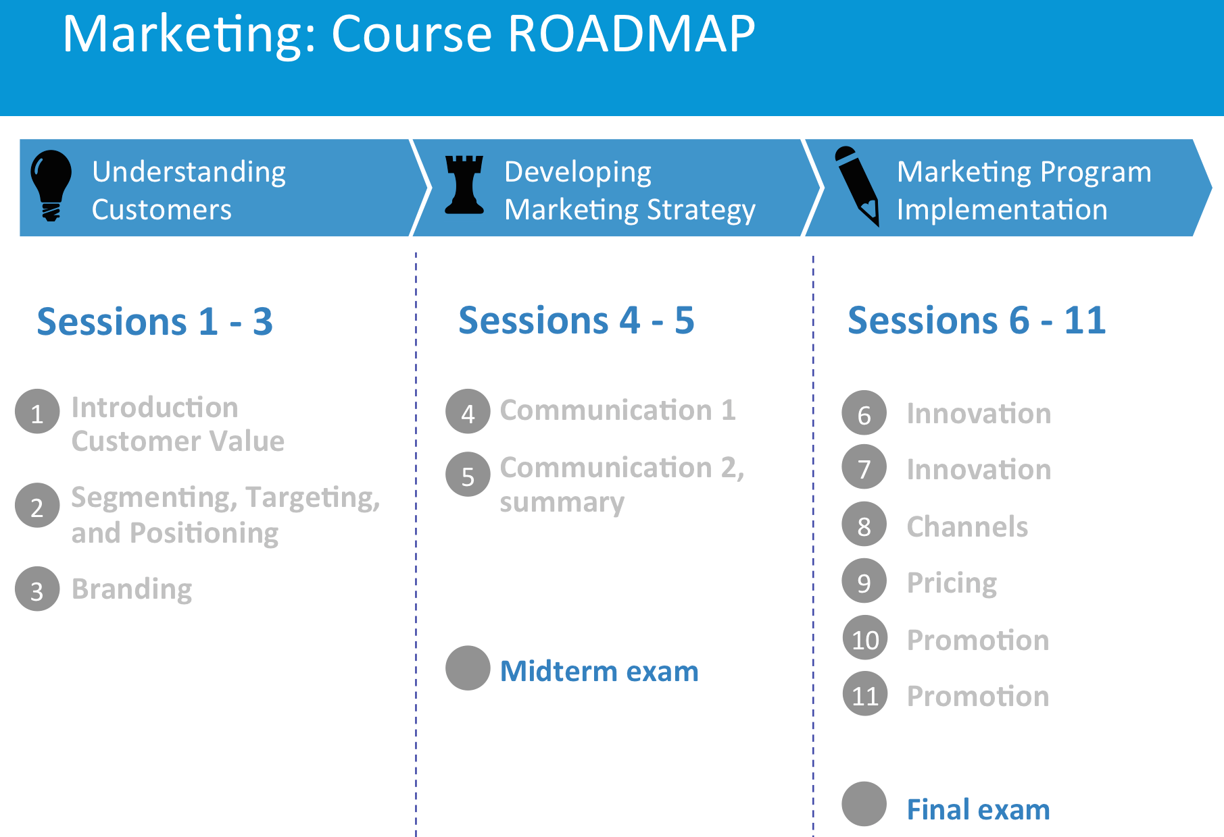

Course Objectives:
B5601 is the core marketing course in the EMBA program at Columbia Business School. This course emphasizes the role of marketing in creating value for customers, which in turn leads to value for other stakeholders in a firm (e.g., owners, shareholders, employees). The main objectives of the course are to improve your ability to:

- Assess market opportunities by analyzing customers, competitors and the strengths and weaknesses of a company.

- Design effective marketing strategies to maximize a company’s chance of winning in the market.

- Develop and evaluate programs designed to implement marketing strategy.

COURSE MATERIAL

Required Reading

The key resources for the course are:

- B5601 Readings and Case Packet
- Lecture notes will be distributed in the class and will be available on the Web site in Canvas.

Optional Reading

If you are interested in additional background reading, we suggest three books.

The first two are relatively encyclopedic references:
- Capon, Noel, Managing Marketing in the 21st Century (2012, 3rd Edition), Wessex.
- Kotler, Philip and Kevin Keller, Marketing Management (2011, 14th Edition), Prentice Hall.

The third emphasizes quantitative and financial aspects:
- Best, Roger J., Market-Based Management - Strategies for Growing Customer Value and Profitability (2012, 6th Edition), Prentice Hall.

OVERVIEW OF CLASS SCHEDULE

A. Understanding Customers and Developing Strategy
Professor Silvia Bellezza
Session | Topic | Case/Readings | Due that day
Session 1  (Sept. 9) | Understanding Customers:  Customer Value | Cases:  - Starbucks: Delivering Customer Service  - Starbucks in the New Millennium  Post-class reading:  - What’s a Customer Worth | Online survey
Session 2  (Sept. 10) | Understanding Customers:  Segmentation, Targeting and Positioning | Case:  - Ombre, Tie-Die, Splat Hair: Trends or Fads? “Pull” and “Push” Social Media Strategies at L’Oréal Paris | Online survey
Session 3  (Sept. 16) | Understanding Customers:  Branding | Case:  - Kate Spade New York: Will Expansion Deepen or Dilute the Brand?  Post-class reading:  - Generating Perceptual Maps from Social Media Data  - Brands and Brand Equity | Online survey
Session 4  (Sept. 23) | Developing Strategy: Communication 1 | Case:  - Casper Sleep Inc.: Marketing the "One Perfect Mattress for Everyone"  Post-class reading:  - Branding in the Age of Social Media | Online survey
Session 5  (Oct. 7) | Developing Strategy: Communication 2 | Case:  - Cheyef Halak: Driving Social Change in Lebanon  Post-class reading:  - Using Social Media Data to Track the Effectiveness of a Communication Campaign | Online survey
October 9th | First (group) assignment due at noon
October 14th | In-class Midterm Exam

Review sessions (Optional):
Date, Time, Place | Agenda
October 10th, 7:00-8:00pm, Warren 309 | Midterm exam review session (optional)

B. Marketing Program Implementation
Professor Kinshuk Jerath
 | Topic(s) | Required Readings | Due that day
Session 6  (October 21) | Innovation:  -Generating new product ideas  -Forecasting the growth of a market (Bass model) | -Ideas Made Here  -Excel and Math primer  -Note on Diffusion Models | -Online Survey #KJ1
Session 7  (October 28) | Innovation:  -Quantifying customers’ preferences for products/services | -Case: Apple vs. Samsung  -Understanding Conjoint Analysis in 15 Minutes | -Online Survey #KJ2 (watch associated video)
Session 8  (November 4) | Channels:  -Which distribution channel(s) to use  -Channel disruption with new technologies | -Case: Bank of America: Mobile Banking  -From Niches to Riches: Anatomy of the Long Tail | -Online Survey #KJ3  -Online Survey #KJ4
Session 9  (November 11) | Pricing:  -Setting price in a distribution channel  -Behavioral aspects in pricing  -Fairness perceptions in pricing | -Mini Case: Deal or No Deal? Pricing Strategies for the Subprime Auto Buyer  -Mini Case: Pricing in Practice | -Second Assignment Stage 1
Session 10  (November 18) | Promotion:  -Quantifying the impact of promotions  -Advertising products and services | -Case: BBVA | -Online Survey #KJ5
Session 11  (December 2) | Promotion:  -Measuring the impact of advertising?  Guest speaker Jonathan Gordon (McKinsey)  Summary |  | -Second Assignment Stage 2
December 16 | In-class Final Exam

Review sessions (Optional):
Date, Time, Place | Agenda
TBD (expected: November 4 lunch hour) | Conjoint analysis review session
TBD (expected: December 12 evening) | Final exam review session

STUDENT EVALUATION

Class Participation / Class Preparedness | 20% | Individual
First Assignment | 15% | Group
Second Assignment | 15% | Group
Mid-term examination | 25% | Individual
Final Examination | 25% | Individual

(1) Class Participation / Class Preparedness

A large portion of the class time will be devoted to analyzing assigned cases, group discussion, and in-class exercises. You will work with your group in a number of in- and out-of-class exercises. We ask that you sit with your study group in class in order to enable quick break-out discussion for in-class exercises.

Several criteria are considered when evaluating your class participation.
- Most important is the quality of the class participation. Sheer quantity is neither sufficient nor necessarily desirable.
- High quality class participation includes comments that add to our understanding of a situation. They go beyond mere repetition of case facts.
- High quality class participation can be supported with qualitative and/or quantitative analysis based on marketing theory and concepts.
- Your comments should take into account the comments and analyses of your classmates. Participation should move our discussion forward.
- Finally, you need to be present in class in order to receive a strong class participation score. Attendance is mandatory in accordance with EMBA program policy.

A note on case discussions: The case method is one of the most effective means of sharpening your decision-making abilities. A case discussion requires that you be an active participant in resolving a marketing problem. The assigned cases are intended to give you practice in assembling data to support a decision. The discussion format provides you with an opportunity to argue your position and to learn from others by listening to their comments, analysis, and criticism. You will learn the most from the cases if you and your classmates prepare and participate fully. You all have different experiences, insights and opinions, and a great deal of what you will learn from the cases will be from each other. It is therefore essential that you be fully prepared for all the cases.

There will be a number of pre-class questions you are asked to answer via online surveys. These have to be completed individually and submitted before 8 am of the day of class. Many of the pre-class questions do not have a unique answer as they depend on how one interprets and uses the data and other information. Our expectation is that you would respond thoughtfully to the questions, giving reasonable justification for your answers. High quality pre-class responses are supported with qualitative and/or quantitative analysis based on logic and marketing concepts.

(2) Assignments

Group assignments are to be done in your learning team. A clear typed-up copy (soft copy) should be submitted online in Canvas on the due date with the name of all team members clearly indicated. No late submissions will be accepted. The clarity of your presentation, reasoning, and analysis are extremely important for receiving full credit for your work. An assignment that is delivered to my snail-mail mailbox or to my office will not be accepted. You can e-mail your homework directly to your TA only under special circumstances.

You are required to submit the following assignments:

First Written Team Assignment – Customer Analysis and Segmentation/Targeting/Positioning Exercise
The assignment will be made available online.
Due by noon, October 9 – upload on Canvas.

Second Written Team Assignment – Product Design Exercise
The assignment will be made available online.
Stage 1: Due by 8:00 AM, November 11 – upload on Canvas.
Stage 2: Due by 8:00 AM, December 2 – upload on Canvas.

(3) Midterm and Final Examinations

The midterm and final examinations will be designed to test your understanding of the topics covered in the lectures, readings, and exercises. The midterm will exam will cover the first half of the course and will be conducted in class on Saturday, October 14. The final examination covers the second half of the course and will be conducted in class. The date is Saturday, December 16.

The construction of reliable, discriminating and valid exams is a very difficult endeavor, and returning exams precludes the use of those test questions for many years. Since the primary goal of the exam in this course is to evaluate students’ knowledge, returning exams would make it more difficult for that goal to be achieved. Therefore, exams will be available in our offices for all of next semester.

LAPTOP POLICY

The school laptop policy will be observed: laptops, tablets, cell phones, and any other electronic devices are strictly prohibited. Please print out whatever quantitative or qualitative analysis you have and bring it to class in order to facilitate discussion.

HONOR CODE

At no time should you use lecture or case notes from previous sections of the course, nor should you violate the Columbia Business School Integrity Code (printed at the beginning of the readings packet) in any other way.

COLUMBIA CORE CULTURE
The purpose of the Columbia Core Culture is to promote a consistent classroom environment of mutual respect, preparation and engagement. Our expectation of you in class is to be:
Present: Your success depends on being on time and present for the entire class every session. Attendance will be part of your grade for class participation and students are expected to sit in their assigned seats.
Prepared: Bring your nameplate, clicker, and complete any pre-work needed for class discussion. Expect the professor to cold call in class.
Participating: Active participation calls for no electronic devices such as laptops, tablet computers, or smartphones during class, except when the professor tells you as part of in-class work.

