EMBA – Fall 2019

B5601: Strategic Marketing

Professors: Silvia Bellezza Andrey Simonov
Uris 508 Uris 524 sbellezza@gsb.columbia.edu asimonov@gsb.columbia.edu

Office hours: By appointment–schedule via email

TAs: Cluster E: Jennifer Sun, sunjennifer916@gmail.com
Cluster M: Malek Ben Sliman, mbensliman20@gsb.columbia.edu

TA office hours: | By appointment–schedule via email

COURSE DESCRIPTION

Marketing activity is at the core of operating a business. It provides the managerial focus to interact with customers and the source of intelligence about consumers, competitors, and the general environment.

The first half of the course focuses on understanding customers and developing a marketing strategy. In order to make effective strategic decisions, managers must identify and measure consumers’ wants, assess the competitive environment, select the most appropriate customer targets and then develop marketing programs that satisfy consumers’ needs better than the competition. Further, marketing focuses on the long-run relationship of a company to its customers as well as short-run sales and profits.

The second part of the course focuses on the decisions that managers make and the tools that they use to implement an effective marketing strategy. The attraction and retention of profitable customers must involve thoughtful and systematic consideration of the product or service being offered, the price, the distribution, and the communication.

Through class projects, hands-on group exercises, case studies, and class discussions, we will explore marketing strategy and its implementation through what is traditionally referred to as the “marketing mix.” As we progress, it will become apparent that all of these decisions deeply are interwoven and that they must all be framed as part of an integrated marketing strategy.
Outline of the Course:

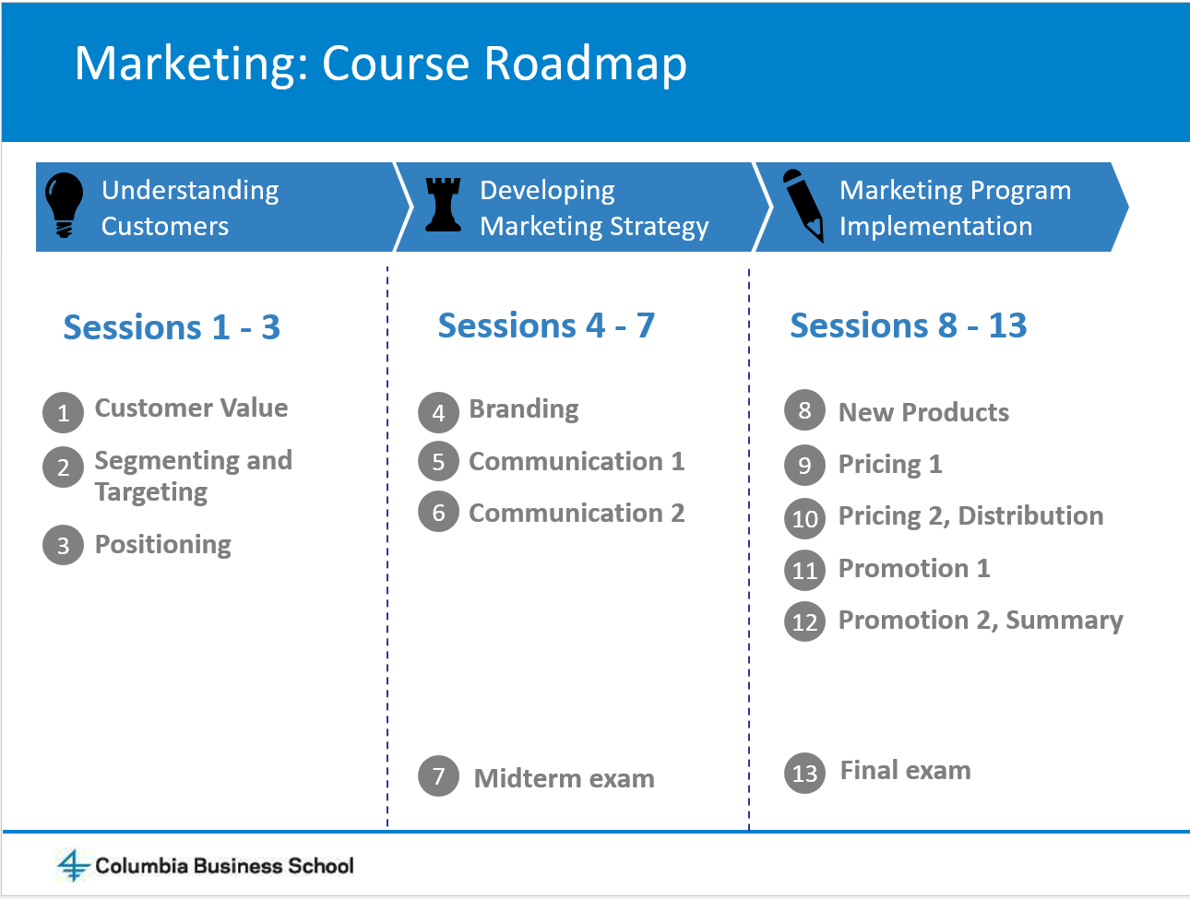

Course Objectives:
B5601 is the core marketing course in the EMBA program at Columbia Business School. This course emphasizes the role of marketing in creating value for customers, which in turn leads to value for other stakeholders in a firm (e.g., owners, shareholders, employees). The main objectives of the course are to improve your ability to:

- Assess market opportunities by analyzing customers, competitors and the strengths and weaknesses of a company.

- Design effective marketing strategies to maximize a company’s chance of winning in the market.

- Develop and evaluate programs designed to implement marketing strategy.

COURSE MATERIAL

Required Reading

The key resources for the course are:

- B5601 Readings and Case Packet
- Lecture notes will be distributed in the class and will be available on the Web site in Canvas.

Optional Reading

We will post on Canvas several optional readings (e.g., academic papers, magazine articles, book chapters) throughout the course.

If you are interested in marketing books, as potential additional background reading, we suggest the following three books.

The first two are relatively encyclopedic references:
- Capon, Noel, Managing Marketing in the 21st Century (2012, 3rd Edition), Wessex.
- Kotler, Philip and Kevin Keller, Marketing Management (2011, 14th Edition), Prentice Hall.

The third emphasizes quantitative and financial aspects:
- Best, Roger J., Market-Based Management - Strategies for Growing Customer Value and Profitability (2012, 6th Edition), Prentice Hall.

OVERVIEW OF CLASS SCHEDULE

A. Understanding Customers and Developing Strategy
Professor Silvia Bellezza
Session | Topic | Case/Readings | Due that day
Session 1  (Sept. 7) | Understanding Customers:  Customer Value | Cases:  - Starbucks: Delivering Customer Service  - Starbucks in the New Millennium  Post-class reading:  - What’s a Customer Worth | Online survey
Session 2  (Sept. 8) | Understanding Customers:  Segmentation and Targeting | Case:  - Chase Sapphire: Creating a Millennial Cult Brand  Post-class reading:  - Rethinking Marketing  - How Blockchain Can Help Marketers Build Better Relationships | Online survey
Session 3  (Sept. 14) | Understanding Customers:  Positioning | Case:  - Ombre, Tie-Die, Splat Hair: Trends or Fads? “Pull” and “Push” Social Media Strategies at L’Oréal Paris  Post-class reading:  - Why Great Innovation Needs Great Marketing | (1) Online survey  (2) Tablet survey  (3) CLV Concept Check
Session 4  (Sept. 21) | Developing Strategy:  Branding | Case:  - Chateau Margaux: Launching the Third Wine  Post-class reading:  - Brands and Brand Equity  - Generating Perceptual Maps from Social Media Data | (1) Online survey  (2) STP Concept Check
Session 5  (Oct. 5) | Developing Strategy: Communication 1 | Case:  - Can 3G Capital Make Burger King Cool Again?  Post-class reading:  - Why Marketing Analytics Hasn’t Lived Up to Its Promise | Online survey
Session 6  (Oct. 12) | Developing Strategy:  Communication 2  Review Session | Case:  - Casper Sleep Inc.: Marketing the “One Perfect Mattress for Everyone”  Post-class reading:  - Using Social Media Data to Track the Effectiveness of a Campaign | Online survey
October 14 | First (group) assignment due at noon
October 19 | In-class Midterm Exam

B. Marketing Implementation
Professor Andrey Simonov

Dates | Topic | Readings | Assignments for class
Session 7  (October 26) | Introduction to Marketing Implementation and New Products | Mini Case: Apple vs. Samsung: The $2 Billion Case  Part 1: https://www8.gsb.columbia.edu/caseworks/RanKivetz/15300  Part 2: https://www8.gsb.columbia.edu/caseworks/RanKivetz/15301  Post-class reading:  - Finding your innovation sweet spot  - B5601 Math Primer  - Understanding Conjoint Analysis in 15 Minutes  - A New Way to Gain Customer Insights | Online survey
Session 8  (November 2) | Pricing | Case: The New York Times Paywall  Post-class reading:  - Principles of Pricing | Online survey
Session 9  (November 9) | Pricing  Distribution | Case: Soren Chemical  Post-class reading:  - Trade Promotion: Essential to Selling through Resellers | Online survey
Session 10  (November 16) | Promotion | Case: BBVA Compass: Marketing Resource Allocation  Post-class reading:  - Marketing Promotions | Online survey
November 23 | Third Assignment Due at 8:30am (Product Design Exercise)
Session 11  (November 23) | Promotion  Course Review | In-class case (read before the class):  - Mini Case: Bazaar.com
December 7 | Final Exam  Time: 1:00pm—4:00pm

Review sessions (Optional):
Date, Time , Place | Agenda
Saturday November 9th, time TBD | Conjoint analysis review session
Saturday December 1st, time TBD | Final exam review session

STUDENT EVALUATION

Class Participation / Class Preparedness | 20% | Individual
First Assignment | 15% | Group
Second Assignment | 15% | Group
Mid-term examination | 25% | Individual
Final Examination | 25% | Individual

(1) Class Participation / Class Preparedness

A large portion of the class time will be devoted to analyzing assigned cases, group discussion, and in-class exercises. You will work with your group in a number of in- and out-of-class exercises. We ask that you sit with your study group in class in order to enable quick break-out discussion for in-class exercises.

Several criteria are considered when evaluating your class participation.
- Most important is the quality of the class participation. Sheer quantity is neither sufficient nor necessarily desirable.
- High quality class participation includes comments that add to our understanding of a situation. They go beyond mere repetition of case facts.
- High quality class participation can be supported with qualitative and/or quantitative analysis based on marketing theory and concepts.
- Your comments should take into account the comments and analyses of your classmates. Participation should move our discussion forward.
- Finally, you need to be present in class in order to receive a strong class participation score. Attendance is mandatory in accordance with EMBA program policy.

A note on case discussions: The case method is one of the most effective means of sharpening your decision-making abilities. A case discussion requires that you be an active participant in resolving a marketing problem. The assigned cases are intended to give you practice in assembling data to support a decision. The discussion format provides you with an opportunity to argue your position and to learn from others by listening to their comments, analysis, and criticism. You will learn the most from the cases if you and your classmates prepare and participate fully. You all have different experiences, insights and opinions, and a great deal of what you will learn from the cases will be from each other. It is therefore essential that you be fully prepared for all the cases.

There will be a number of pre-class questions you are asked to answer via online surveys. These have to be completed individually and submitted before 8 am of the day of class. Many of the pre-class questions do not have a unique answer as they depend on how one interprets and uses the data and other information. Our expectation is that you would respond thoughtfully to the questions, giving reasonable justification for your answers. High quality pre-class responses are supported with qualitative and/or quantitative analysis based on logic and marketing concepts.

(2) Assignments

Group assignments are to be done in your learning team. A clear typed-up copy (soft copy) should be submitted online in Canvas on the due date with the name of all team members clearly indicated. No late submissions will be accepted. The clarity of your presentation, reasoning, and analysis are extremely important for receiving full credit for your work. An assignment that is delivered to my snail-mail mailbox or to my office will not be accepted. You can e-mail your homework directly to your TA only under special circumstances.

You are required to submit the following assignments:

First Written Team Assignment – Customer Analysis and Segmentation/Targeting/Positioning Exercise
The assignment will be made available online.
Due by noon, October 14th – upload on Canvas.

Second Written Team Assignment – Product Design Exercise
The assignment will be made available onl3ine.
Due by 8:30am, November 23rd – upload on Canvas.

(3) Midterm and Final Examinations

The midterm and final examinations will be designed to test your understanding of the topics covered in the lectures, readings, and exercises. The midterm will exam will cover the first half of the course and will be conducted in class on Saturday, October 19th. The final examination covers the second half of the course and will be conducted in class. The date is Saturday, December 7th.

The construction of reliable, discriminating and valid exams is a very difficult endeavor, and returning exams precludes the use of those test questions for many years. Since the primary goal of the exam in this course is to evaluate students’ knowledge, returning exams would make it more difficult for that goal to be achieved. Therefore, exams will be available in our offices for all of next semester.

LAPTOP POLICY

The school laptop policy will be observed: laptops, tablets, cell phones, and any other electronic devices are strictly prohibited. Please print out whatever quantitative or qualitative analysis you have and bring it to class in order to facilitate discussion.

HONOR CODE

At no time should you use lecture or case notes from previous sections of the course, nor should you violate the Columbia Business School Integrity Code (printed at the beginning of the readings packet) in any other way.

COLUMBIA CORE CULTURE
The purpose of the Columbia Core Culture is to promote a consistent classroom environment of mutual respect, preparation and engagement. Our expectation of you in class is to be:
Present: Your success depends on being on time and present for the entire class every session. Attendance will be part of your grade for class participation and students are expected to sit in their assigned seats.
Prepared: Bring your nameplate and complete any pre-work needed for class discussion. Expect the professor to cold call in class.
Participating: Active participation calls for no electronic devices such as laptops, tablet computers, or smartphones during class, except when the professor tells you as part of in-class work.

