Management B8519 Section 2
Launch Your Startup Fall 2019
(Full Term: September 3rd – December 10th)

Room: Uris Hall, Room 331
Day/Time: Tuesday 2:15PM - 5:30PM

Professors: Jack McGourty, Ph.D.
Director of Community and Global Entrepreneurship
Founder, Venture For All®
Columbia Business School
Office: Uris 325A
Mobile: 646-470-3193
E-mail: jm723@columbia.edu
LinkedIn: http://www.linkedin.com/in/jackmcgourty

William J. (Bill) O’Farrell
Adjunct Associate Professor Columbia Business School
Office: TBD
Mobile: 401-965-6400
Email: wo2148@columbia.edu
LinkedIn: http://www.linkedin.com/in/williamjofarrell

Introduction
This “hands-on” applied course focuses on the creation, evaluation, development and launch readiness of a new business or social venture. For each new venture, key issues are addressed in a fashion highly consistent with other formal venture planning processes including: business model development, customer discovery, product-market validation, in-depth industry and market analysis, product or service innovation, brand development and go-to-market strategies, team selection & management, profit models, financing, and legal considerations. Throughout the class students will refine their venture’s business model based on instructors’, visiting domain experts, peer, customer, and investor feedback.

To enroll in this class, you should have a “vetted” business or social venture concept prior to joining the class. A previously vetted venture concept includes ideas that have been worked on in earlier MBA or other graduate classes, presented in formal venture competitions, or formulated within formal venture creation program outside of University, as in events or classes specially targeting aspiring entrepreneurs. You are allowed to join the class as part of a venture team (within or external to the class) who has been working on a new business idea prior to the class. It is entirely permissible to change projects (“pivot”) or join another peer team after the class has started. Working individually or preferably in teams (of no more than four), students spend the entire term developing an effective and comprehensive plan for a “real” venture concept, with proof of concept including customer-based market validation and early product/service prototypes. Students complete the class with a comprehensive new venture planning document, investor pitch, a minimal viable product, and validated business model.

New venture ideas must be something that the student(s) are passionate and are capable of near term execution. In other words, the new venture “must” be doable. Projects should reflect students’ genuine interest, but do not need to be tech-centric, venture capital-type projects or even "for profit" (many successful non-profits have taken LYS). If a project is based upon a student’s idea, then unless a written agreement states to the contrary, the ownership of the idea and the work done during the semester is the property of the student(s) who had the original idea. All participants sign a non-disclosure agreement so we can engage in open discussions about each other’s ventures. By the second week of class, all students are expected to solidify the venture concept they wish to pursue throughout the term or have joined another team. There can be no changes in venture or team membership after the fourth week.

Prerequisites
Columbia Business School’s entrepreneurship curriculum is organized around a sequence of three “spine” courses: (1) Foundations of Entrepreneurship; (2) Launch Your Startup; and (3) Entrepreneurial Greenhouse.

Foundations of Entrepreneurship serves as a prerequisite for those interested in enrolling in Launch Your Startup. It provides a broad survey of concepts and concrete skills that benefit not just aspiring entrepreneurs, but also those who want to invest in new ventures and/or work for a startup. Foundations of Entrepreneurship is especially appropriate for students who (a) have limited or no experience in the startup world, or (b) have some experience but do not yet have a fully developed and vetted business idea or team.

Launch Your Startup is an accelerated, applied class for students who are already actively engaged with their target market, ready to advance their customer discovery and market research, design and test minimum viable products (MVP’s), develop customer acquisition strategy, and prepare investor-ready financials for fundraising.

Students who already have an MVP and have completed customer discovery can apply to enroll in Entrepreneurial Greenhouse, which is designed as an accelerator.

Exemption Protocol: If you believe that you should be enrolled in Launch your Startup without having to take Foundations of Entrepreneurship, please complete the following exemption survey - http://bit.ly/entrepreneurwaiver. Your request should be brief but specific, including relevant background information (e.g., entrepreneurship coursework and work experience) and any progress you’ve made on your idea to date (e.g., customer discovery). Please allow at least one week for a response, as your request may require deliberations among faculty.

NOTE: Following school policy, students MAY NOT enroll in Foundations of Entrepreneurship and Launch Your Startup concurrently.

Grading: Student grades are based on timeliness of submission, research efficacy, comprehensiveness, and overall quality of major deliverables throughout the class. The majority of the grade is based on collaborative work with the exception of 12 points allocated to individual class reflections. Assignments are to be submitted when due. Late assignments are subject to point reduction. Attendance is required as per CBS policy and attending the first class is mandatory as class requirements are discussed in detail. All of your assignment submissions are subject to the CBS Honor Code. Violations of the CBS Honor Code may lead to failing the assignment, failing the course, suspension, and/or dismissal.

Customer Discovery and MVP Results & Feedback 20 Points
Final Venture Presentation 10 Points
Executive Summary Package 15 Points
Weekly Assignments (43pts), Class Reflections (12pts) & Active Class Engagement 55 Points

Course Description
This course deepens the students understanding of entrepreneurship and innovation practices by guiding them through the new venture creation process as applied to an enterprise idea of their choice. Students, through interactive lectures, short cases, guest speakers, and self-directed assignments, learn the core elements of venture creation and planning in a specially sequenced modular format. Each module provides the participant with the knowledge and tools required to develop a comprehensive new venture plan. At each stage, students are exposed to critical terms, tools that support research and decision making, and explanations of how each major planning activity fits into the new venture creation process.

During each module, students respond to a series of venture questions and exercises, guiding them through the planning process in a self-directed manner. Students identify and evaluate a venture opportunity, assess the industry and market attractiveness for their venture ideas, form competitive strategies, develop minimum viable products and services, and generate full financial statements. This course allows students to hone such professional skills as creative problem solving, oral and written communication, project management, financial analysis, and effective team leadership. See Tables 1 and 2 for list of topics, focus areas, and associated assignments.

Modules 1-3: Opportunity. Participants are stepped through each element of a formal venture process, including how to evaluate their progress at each major juncture. Participants develop a venture concept summary that details early assumptions about their venture's proposed business model. Key focus areas include the consumer problem or pain point to be solved, opportunity or need that the venture addresses; defined value proposition for all relevant customers & stakeholders, assessment of preliminary target market in terms of size and segmentation, initial description of proposed product or service; identification of distribution channels the product or service will need to reach the market, and explanation of unique end-user benefit, why a customer will pay for said solution. An overall business model is generated describing the following components: value proposition and rationale for customer and market selection (product-market fit); the scope and channels for products/services offered by your venture; proposed organizational design including key activities, resources, and partnerships; and initial assumptions on revenue streams and cost structures. Participants refine this preliminary business model throughout the class.

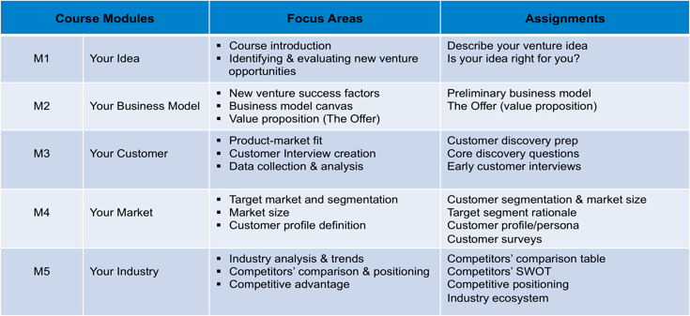

Table 1. Course Modules (1-5), Core Topics, Key Focus Areas, & Assignments

Modules 4-5: Strategy. New venture strategies are developed with an emphasis on competition, globalization and market potential for their new ventures. Participants conduct comprehensive analysis of the competitive landscape, identifying key competitors in their industry sector, and exploring their respective business models. Participants assess the targeted market size and industry, discover how to obtain market feedback and validation on market acceptance, develop product features that align with the stated value proposition, generate pricing assumptions, and, learn how to evaluate the industry or niche in terms of maturity and growth potential. From this analysis, participants identify a sustainable competitive advantage, capitalizing on internal strengths and mitigating any challenges and threats from the external environment.

Modules 6-7: Innovation. Product innovation is explored and participants develop a roadmap for development and market testing. One of the main activities at this juncture is the development of a minimum viable product. Participant teams illustrate the essential features of their product or service through such techniques as concept boarding, sample web pages, and process charts. Additionally, participants learn the basics of product or service pricing, marketing strategies and promotional tactics with a focus on product positioning, branding, marketing mix, and the optimal way to price, promote, sell, deliver, and service the customer.

Modules 8-10: Leadership. All the research and decisions come together to support assumptions required to build the overall revenue and profit models for the business. Participants build a preliminary financial plan based on projected revenues, cost of goods, and anticipated operating costs. Participant venture teams generate a three-year projected income statement and cash flow analysis. Various sources of capital for venture funding are discussed and participants define how much capital is needed and how it will be used. Recruiting and selecting team members for new ventures has its challenges, especially when there are many skills required, but limited resources. This module explores strategies and tactics to bring together the right set of players that will provide the required expertise and core competencies needed to meet the new venture’s value proposition as well as position the company for future growth. Looking for co-founders and partners, managing family relationships, partnering with complimentary organizations will be explored in relation to the participants’ ventures. Core principles of organizational design and culture creation will be discussed. Finally the role that corporate social responsibility can play in achieving financial goals is explored.

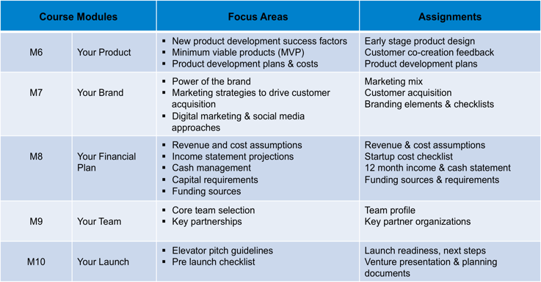

Table 2. Course Modules (6-10), Core Topics, Key Focus Areas, &

Course Assignments
Weekly Assignments, Class Reflections & Active Class Engagement (55 Points). Throughout the course, students apply a sequenced series of activities and exercises to support their new venture development. Weekly assignments (43 points), based on class topics, are structured to lead founders and teams through the steps required to form a new venture, from initial concept through execution plan. Students submit these assignments weekly and are provided with timely feedback prior to the next assignment so that comments and be incorporated into their work as the project moves forward. Additionally, students are encouraged to participate in class discussions, provide peer feedback, engage guest speakers, and offer insights from their own venture work. At the end of each class, individual students are asked to respond to a number of reflection questions (12 Points) designed to align what has been discussed in class with their venture projects. Finally, students are encouraged to schedule individual or team meetings with the faculty outside the class for individualized discussions regarding venture development. Faculty offers weekly in-person and web-based office hours with plenty of flexibility to support on-going venture work.

Customer Discovery & MVP Results and Feedback (20 Points). Detailed documentation on two major customer development activities: 1) Customer Discovery Interview Section includes: Interviewed customer sample size and demographics, data findings focusing on assumptions validated and invalidated, summary of changes to venture and product offering due to customer discovery findings, and all interview protocols, scripts, & survey questions; 2) MVP Test Feedback Section includes: Details of your MVP test design, test participants demographic information, results from the MVP test including customer feedback, and plans for MVP 2
Final Venture Presentation (10 Points). Students deliver a timed “pitch,” providing an opportunity to share the venture idea with peers, faculty, and investors. Participants receive constructive feedback on various elements of the business models as well as on their presentation skills. The presentation is designed to complement the final venture planning document.

Executive Summary Package (15 points). Executive Summary Package for Investors is a set of “branded” companion documents that provides descriptive, narrative highlights of your venture business model and execution plans. The package includes the following three documents: 1) Detailed Slide Deck which provides a comprehensive view of your business model and execution plan. This deck should be developed based on your weekly assignments and rolling slide deck submissions. 2). A two-page narrative based Executive Summary Document covering key points on your opportunity, target customer, market size & industry growth trends, competitive analysis & strategy, product offering & value proposition, financial highlights & capital requirements, and team profile, and 3) 36-month Financial Statements including detailed assumptions (P&L and Cash Flow Statements required, balance sheets optional)

Attendance Policy
Students are required to attend each class. Students should reach out to the instructor or TA regarding excused absences (for religious observances; personal, medical, and family emergencies; military service; court appearances such as jury duty). Unexcused absences will affect your course grade. The first session is mandatory to be considered enrolled in the class.

Inclusion, Accommodations, and Support for Students
At Columbia Business School, we believe that diversity strengthens any community or business model and brings it greater success. Columbia Business School is committed to providing all students with the equal opportunity to thrive in the classroom by providing learning, living, and working environment free from discrimination, harassment, and bias on the basis of gender, sexual orientation, race, ethnicity, socioeconomic status, or ability. Columbia Business School will make reasonable accommodations for persons with documented disabilities. Students are encouraged to contact the Columbia University’s Office of Disability Services for information about registration. Students seeking accommodation in the classroom may obtain information on the services offered by Columbia University’s Office of Disability Services online at www.health.columbia.edu/docs/services/ods/index.html or by contacting (212) 854-2388. Columbia Business School is committed to maintaining a safe environment for students, staff and faculty. Because of this commitment and because of federal and state regulations, we must advise you that if you tell any of your instructors about sexual harassment or gender-based misconduct involving a member of the campus community, your instructor is required to report this information to a Title IX Coordinator. They will treat this information as private, but will need to follow up with you and possibly look into the matter. Counseling and Psychological Services, the Office of the University Chaplain, and the Ombuds Office for Gender-Based Misconduct are confidential resources available for students, staff and faculty. “Gender-based misconduct” includes sexual assault, stalking, sexual harassment, dating violence, domestic violence, sexual exploitation, and gender-based harassment. For more information, see http://sexualrespect.columbia.edu/gender-based-misconduct-policy-students.

Course Management Platform
The program is facilitated by the use of Columbia Business Schools course management system, called CANVAS. Faculty use this system to provide participants with class materials, encourage student engagement, and interaction with course content, receive assignment submissions, and create two-way dialogue on venture work. In order to gain the most from the program, students should bring their laptops to class and have reliable Internet connectivity and bandwidth outside of class to be able to download program materials and watch associated videos.

Course Faculty
Jack McGourty Ph.D. is Director of Community and Global Entrepreneurship at the Columbia Business School and a faculty member teaching courses in entrepreneurship; venture creation, and emerging global markets. Since joining the Business School, Jack has taught "Launch Your Startup" (formerly Launching New Ventures) every semester. Prior to joining the Columbia Business School, Jack was Vice Dean for Columbia’s Engineering School. Over the past 21 years, Jack has been an active member of the University's entrepreneurial community, establishing an undergraduate minor in entrepreneurship, teaching core and advanced courses in new venture creation & growth, and launching the Columbia-Harlem Small Business Development Center. Jack is the driving force behind Venture for All®, a program designed to educate aspiring entrepreneurs and build capacity for high potential startup ventures in emerging global markets. Prior to coming to Columbia in 1998, Jack was a senior executive and board member for a large publicly traded company. During his tenure, Jack held several senior positions including vice president of human resources, executive vice president of operations, division president, and company president & chief operating officer. He was also the managing principal of Assessment Alternatives Inc., a consulting firm providing programs and services to medium and large companies on new business development, innovation and product realization.

William J. (“Bill”) O'Farrell has been starting and running tech companies for longer than he’d like to admit. He is currently co-founder and CEO of Body Labs, Inc., which is using 3D digital body models to help change how businesses interface with their consumers. He is also an Adjunct Professor at the Columbia Business School where he teaches Launch Your Startup. Formerly, he was co-founder and CEO of such companies as SpeechWorks (NASDAQ:SPWX), acquired by Nuance (NASDAQ:NUAN), OpenAir.com, acquired by Netsuite (NASDAQ:N), and the Company of Science & Art, which created the After Effects product line, acquired by Adobe (NASDAQ:ADBE). Bill has been involved as a founder, CEO, advisor, consultant and bottle washer at numerous companies in the software, biotech, consumer and investment sectors. He also owned and ran a small organic beef farm. Bill believes he’s made every mistake possible at least twice, so he reckons he might actually know something now. When not CEO'ing, he surfs, ski and dances enthusiastically, frequently injures himself playing a sport he should have stopped playing years ago, and laments that he's read every good historical novel out there. His French is good, though rusty, his Spanish less of one and more of the other. He received his undergraduate degree from Brown University and is somewhat embarrassed to admit that he was briefly a lawyer, having been trained (some say house broken) at Harvard Law School. Other educational endeavors included a year of graduate work at the University of Nice, France under a Rotary Foundation Scholarship. Bill also completed the New England Clean Energy Council Fellowship in July 2009.

