B8507 ORGANIZATIONAL CHANGE – Fall ‘18 B Term
Draft v. 2.0 (June 2018)

Professor: Todd Jick
Office: Uris 721
E-mail: tdj2105@columbia.edu
Office Hour: By appointment
Voice: 212.854.9252

TA: Ellen Chu TA: Kristin Cummings

B8507-001 Tues/Thur 9:00am – 10:30am B8507-002 Tues/Thur 10:45am – 12:15pm
Uris 142 Uris 142

Schedule – Attendance Expectations : PLEASE ADJUST Your Calendars

- Attendance at first class is mandatory for all enrolled students, as well as those on a waitlist or who hope to add the class during add/drop.
- You must attend class in your registered section, and be part of all group projects with your team (Class 6 and Class 9).

INTRODUCTION

This course is focused on the nature and process of organization change, and how to be an effective leader, implementer, and recipient of change. It emphasizes the forces for change, the change implementation process, the qualities and skills of successful change leaders, and the behavioral theories and management practices of how individuals and organizations change. Finally, it will help you to better diagnose the change agendas of organizations you will be joining to help prepare for your experience as leaders, implementers, and/or recipients of change.

Course Logic

The course has three modules:

Module I (Classes 1-5) highlights the Leadership of Change from the top, the major types and drivers of large scale organizational change—e.g. strategic, leadership, cultural, structural, ownership—and the commonalities and differences among these transformations. Some of these are “long marches” in which there are gradual, incremental changes through multi step change processes; others are “bold strokes” in which major, short changes are instituted and their impact immediately felt. Some are changes to stimulate growth, and some are downsizing and cost cutting oriented. The goal here is for you to get a good “feel” for how these major types of transformations unfold, how well the changes were instituted, sources of resistance encountered, and how leaders are involved in the whole endeavor. And we will focus on the impact of change on employees as it ripples from the top of an organization.

Module II (Classes 6-10) gives you a chance to practice with implementation tools and techniques and the ingredients for successful change management. We will start with a Merger Integration implementation role play. We will next ask you to make a series of decisions to manage downsizing in a brokerage firm, called Sterling. Next, we will practice under cross cultural conditions and add a new dimension to applying change management. You will then test your implementation acumen in a real world based simulation of being change agents in an organization, introducing change in a planful way to a Business unit. To personalize the challenge of implementation, we will conclude with cases of “young” change agents in action and examine what it is like to influence and implement change from “below” or the “middle” of an organization.

The course concludes with Module III (Classes 11-12). The first class is New Vistas in which you will reflect back on your own experiences with change, bringing a new perspective to your own experience gleaned from Org Change, and compare experiences with fellow students in different industries and geographies. This module concludes with how to develop the underlying organizational capacity to change—to build a change friendly, continuously improving organization.

Course readings can be found on Canvas in the calendar section under each given class (if you have any trouble opening links, please contact your TA.) There will also be a course book which contains all CBS and HBS materials. You will probably find it useful as well to copy some of the linked required readings and bring to class for reference.

COURSE SYLLABUS AND SCHEDULE

Module I: Leading Change I

Session 1: The World of Organizational Change: Leading, Implementing and Experiencing Change (Thursday, Oct 25)

Topic—How well do organizations (in this case, Apple) handle changes they want to make? How can individuals (in this case, Donna Dubinsky) handle changes that suddenly are thrust on them?

Required Readings:

  - Case: Donna Dubinsky and Apple Computer (A) (Jick).
  - Concept: “All Management is Change Management” Robert Schaefer, HBR, Oct 26, 2017, 3pp.
  - Concept: “Introduction: The Challenge of Change,” Managing Change, Jick and Peiperl, pp. xix-xxvii, 2011, 3rd Edition.
  - Application: “Best Practices in Change Management—Executive Overview, 2014 Edition”, Prosci Benchmarking Report, 2014.

Assignment Questions:

Read case--Donna Dubinsky and Apple Computer (A) -- and the readings-- and prepare for our class discussion with these questions (no need to hand in):
- Why was Donna initially so successful?
- How and why did things unravel for her?
- How would you have handled the situation differently?
- What is “typical” of organizational change issues based on the accompanying articles?

Session 2: Leading Change II: Evolutionary and Revolutionary Change
(Tuesday, Oct 30)

Assignment: Read the Case, and accompanying readings and be prepared to discuss the following:

- How and why did Komansky change Merrill Lynch? Was he successful and effective overall?
- How and why did O'Neal change ML? Was he successful and effective overall?
- How well did Thain lead change for ML?
- What lessons do you take from the decade-long Merrill Lynch story about how to manage change?

Required Readings:

  - Case: “Merrill Lynch—Evolution, Revolution, and Sale, 1996-2008” CBS, Jick.
  - Case (2): “Subprime Suspect: “The Man Merrill Lynch Loved to Hate” New Yorker, March 31, 2008 (Abbreviated).
  - Application: “Putting the Muscle Back in the Bull--Stan O’Neal May Be the Toughest--Some say the most ruthless--CEO in America. Merrill Lynch Couldn’t Be Luckier to Have Him”, Fortune, April 5, 2004.
  - Application: “Whatever Happened to Mother Merrill?,” The New York Times, August 3, 2003.

Video: David Komansky, former CEO, Merrill Lynch

Session 3: Leading Change III: When to Change? Who to Involve? Approaches to Change Management (Thursday, Nov 1)

Assignment: Read the required readings and be prepared to discuss the following:

- What was at issue in this situation overall?
- Who were the key stakeholders and what should their appropriate level of involvement have been? When should they have been involved?
- How effective was Reinharz in his tenure at Brandeis? In his handling of the Rose Art Museum issue? What should he have done differently?

Required Readings:

- Case: “Brandeis University: Selling Art or the Art of Selling,” CBS, Jick.
- Concept: “Implementing Change”, Todd Jick (HBS Note, No. 9-491-114).
- Application: “Leadership Tips for College Presidents and CEO’s,” Glassner and Schapiro, WSJ, April 29, 2014.
- Concept and Application: “Why It’s So Hard to Be Fair,” Joel Brockner, HBR, March 2006.

Optional Readings:

- Application: “Rutgers—How NOT To Manage Organizational Change”, WSJ, J. Baldoni, April 2013.
- Application: “Learn from CUNY: Lessons of Goldstein’s Success” Roger Hertog, NY Post, Aug 3, 2013

Session 4: Leading Change IV: Key Ingredients of Successful Transformation—“Long Marches” (Thursday, Nov 8)

Assignment: Read the Cadbury (C) and (D) cases and accompanying readings about merger integration:
- What were the change integration challenges after the merger?
- How well were they handled?
- What could have been done differently/better? What to do now?

Required Readings:

  - Case: “Cadbury Schweppes: Capturing Confectionary, (C),” Collis, Stuart and Smith, 2008.
  - Case: “Cadbury Schweppes: Capturing Confectionary, (D),” Collis, Stuart and Smith, 2008.
  - Concept: “Why Organizations Succeed: Assessing Change Strategy”, The Challenge of Organizational Change, Kanter, Stein and Jick, pp. 490-495

Optional Reading:

- Concept/Application: “The Key to Campbell Soup’s Turnaround? Civility” C. Porath and D. Conant, HBR, Oct 5, 2017, 6pp.
- Concept/Application:” Secrets of Successful Change Implementation” Johnston, Lefort and Tesvic, McKinsey Quarterly, October, 2017, 9pp.

Video: Matt Shattock, formerly Cadbury Head of Americas Confectionery and currently, CEO, Beam Global

Session 5: Leading Change V: “Bold Strokes”…Private Equity based Organizational Change (Tuesday, Nov. 13)

Assignment: The “Case” here is 6 mini cases below—one on Reader’s Digest (a), one on Heinz (b), one on 3G (c), HTPG-skim (d), First Data-skim (e), and Skype (f). They are all interesting, especially in comparison to each other. Read or skim as instructed below.

These are classic PE examples of “distressed businesses,” which will be our focus in this class (there are of course many different kinds of PE activity including growth businesses). Also included are the consulting firm approaches of Bain Capital (g) and BCG (h)

- What are the special features of Organizational change brought about in the aftermath of private equity ownership? (E.g. Timeframe? Philosophy? Constituents? Etc.)
- Under conditions of PE ownership, is it easier or more difficult to implement and sustain change?
- How would you assess the likely effectiveness of change at the 6
case examples and in “bold stroke” situations?

Required Readings:

  - Case: (Reader’s Digest): “Impatience,” Forbes, June 16, 2008. (2pp)
  - Case: (Heinz) Case: “Brazilian Style—Tightfisted New Owners Put Heinz on a Diet”, Annie Gasparro, WSJ, Feb 11, 2014.
  - Case (3G): “What Happens When 3G Capital Buys Your Company” 2015. http://fortune.com/2015/03/25/3g-capital-heinz-kraft-buffett/
  - (Skim) Case (HTPG): “We’re From Private Equity, and We’re Here to Help”, Brendan Greeley, Business Week, May 6, 2012, pp. 55-59.
  - (Skim) Case (First Data): “How First Data Reinvented Itself to Become 2015’s Biggest IPO” Fortune, Oct 2015. http://fortune.com/2015/10/21/first-data-ipo/
  - Case (Skype): “How Employees Get Totally Screwed in PE Deals,” Yee Lee, June 24, 2011, http://www.businessinsider.com/how-employees-get-totally-screwed-in-private-equity-deals-2011-6
  - Concept: “How Can PE Lessons Apply to You”, Chapter from Lessons from Private Equity Any Company Can Use, Gadiesh and MacArthur, 2008.
  - Application: “100 Day Plan,” BCG, 2017.

Optional Reading:

- Concept: “Private Equity’s New Phase” Dave Ulrich and J. Allen, HBR, Aug 9, 2016.

Module 2: Implementing Change: Tools, Techniques, Applications

Session 6: Implementing Change I: Managing a Merger – What, When, How and Who to Change (Thursday, Nov 15 )

Assignment:
Please read “AlphaNet and OmegaCom” case, and the assigned readings below, and have your TEAM submit the answers to the following:

- You are the AlphaNet CEO and you have decided to convene a first meeting of the top management of both companies shortly after the merger. You have decided to use up to the first 10 minutes to introduce yourself and your thinking about change. Please write your speech in no more than 3-double spaced pages. (Assign one person in your group to be prepared to deliver it).
- What 5 questions would you most expect the audience to ask you and provide your brief answers to those questions. (One double spaced page)
- The speech will be followed immediately by an all-day offsite. Provide an outline of what the agenda and design would be for the remainder of the day. (One double spaced page)

Please put all student names and class section on the cover page and submit electronically to your TA before your class. Please underline or asterisk the student name chosen by the team to give the speech--time permitting-- in class.
BRING TWO HARD COPIES OF YOUR ASSIGNMENT TO CLASS (ONE FOR THE TA AND ONE FOR PROF JICK)

Required Readings:

- Case: AlphaNet and OmegaCom, 2010, CBS, Jick.
- Application: “Laying the Foundation for Communicating Change”, Perfect Phrases for Communicating Change, Lawrence Polsky & Antoine Gerschel, 2010, p. 1-17.
- Concept: “The Balance Needed to Lead Change,” Harvard Management Update, Kerry Bunker and M. Wakefield, Nov 2008, pp. 4-6.
- Concept: “Change Management in M&A Integration,” PWC, March 2017, 9pp.

Optional Readings:

- Application: “Full Text: US Airways CEO Merger Memo to Workers” Feb 14, 2013; http://www.usatoday.com/story/todayinthesky/2013/02/14/full-text-us-airways-ceos-merger-memo-to-workers/1918803/
- Application: “Read the Emotional Speech LinkedIn CEO Jeff Weiner gave employees after the Microsoft Deal,” Chris O’Brien, Venturebeat.com, June 17, 2016.

Session 7: Implementing Change II and Experiencing Change I: Managing a Downsizing and the Recipients of Change (Tuesday, Nov 20)

Assignment:
Read Implementing Change at Sterling & Co, and the readings, and then:
- Fill in your answers to Sterling & Co Exercise and bring to class for discussion. ANSWER ALL QUESTIONS before coming to class!
- Rewrite the memo from the CEO as you would like it to say…(bring to class for use, time permitting)
- What are the keys to understanding and managing “recipients of change”?
- How do you know the difference between “good” and “bad” resistance?

Required Readings:
- Case/Exercise: “Implementing Change at Sterling & Co.”, CBS, Jick, 2017.
- Concept: “The Recipients of Change”, HBS, Jick, 9-491-039.
- Application: “How to Communicate Layoffs”, Harvard Management Update, Robbins, April 2009, pp. 11-12.
- Application: “Why Your Company Need More Ceremonies” Patti Sanchez, HBR, July 27, 2016
Optional Readings:
- Concept: “Leading Transition”, On Leading Change, Bridges and Mitchell, 2002, pp. 33-45.
- Case: “Do you really think we are so stupid?” A letter to the CEO of Deutsche Telecom (A)” 2013 ESMT Case Study.

Session 8: Implementing Change III: Cross Cultural Change Management (Tuesday, Nov 27)

Assignment: Read two cases and two readings about cross cultural change management:
- Cases: “Cross-Border Change Management: Darlene Adams and Alex Petrov,” CBS, Todd Jick, 2018

Discussion Questions (Darlene Adams)
- Why were things at an impasse? In what ways was this a cross cultural issue?
- What would you have done differently if you were Darlene?
- What would you do now?

Discussion Questions (Alex Petrov)
- What is the “problem” to solve here?
- How well are things going?
- What would you have done differently if you were Alex?
- What would you do now?

- Concept: “Navigating the Cultural Minefield,” Erin Meyer, HBR, May, 2014
- Concept: “How to Successfully Work Across Countries, Languages and Cultures, Tsedal Neeley, HBR, Aug 29, 2017.

Session 9: Implementing Change III: Managing a Product and Market Transformation (Thurs, Nov 29)
(PREP OUTSIDE OF CLASS, AND THEN WE WILL RUN COMPUTER SIMULATION IN CLASS )

Assignment:
- Complete Part I simulation prep with your team outside of class, and bring your implementation plan to CLASS 8/9.(BRING HARD COPY TO CLASS )
- What are the underlying assumptions behind your Implementation Plan?

Required Readings:

- Concept: Global Tech Simulation—Change Theory
- Case: Global Tech Simulation-- Players Guide.
- Application: “10 Great Things Leaders Do to Get People on Board,” Margie Warrell, Forbes, April 15, 2017.
Optional Readings:

- Application: “Due Diligence in a Change Management Project” Callie McDowell, Change Management Review, 2017
- Application: “FC Barcelona: A Story of Successful Lasting Change,” Jordi Texido, Oct 2014.

Session 10: Implementing Change IV: Leading Change from “Below” (Tuesday, Dec. 4)

Assignment: Please Read the 4 mini cases about young change agents and one reading:

- What do you admire about the Young Change Agents’ plans and thinking? What aspects are sound in their thinking?
- Where could they stumble? How would you have advised them to approach the change and their (future) jobs differently?
- What is humbling and exciting about the task of driving change from below?

Required Readings:

- Case: “Susan Baskin: Aspiring Change Agent (A)”, CBS, Jick.
- Case (Chew Lin Tan): “Change Agent in Waiting”, CBS, Jick.
- Case: “Henry Silva: Aspiring Change Agent for a Start Up Company”, CBS, Jick,
- Case (James Shaw): “Firestarters,” Bill Breen and Cheryl Dahl, Fast Company, 11-30, 1999.
- Application: “Leading From Below”, Wall St. Journal, James Kelly and Scott Nadler, March 3, 2007.

Optional Readings:

- Application: “Managing Upward for Success” Jonathan Aberman, Washington Post, Nov 13, 2017, 2pp
- Application: ”Blackrock Tries to Do Good Investing After Millenials Convince Fink”, 2015.
- Concept: “How to Disagree with Someone More Powerful Than You,” Amy Gallo, HBR, March 17, 2016
- Application: “5 Mistakes Employees Make When Challenging the Status Quo” Lois Kelly and Carmen Medina, HBR, Nov 14, 2016.

Module 3: New Vistas for Organizational Change and Building Capacity to Change

Session 11: New Vistas—Reflecting on Your Past (Thursday, Dec 6)

Today’s class will allow us to sample a variety of Organizational Change situations and issues which we did not cover in class to date, or which we can now explore in more depth. Every student will bring something to give” to others—e.g. knowledge, experiences, change techniques, questions and/or takeaways, and every student will have the opportunity to sample and learn from these many inputs during our class. Your “entry ticket” is to bring something others will find interesting and useful, and expand their horizon and “vistas”! If so, you will exit with lots of ideas you will have gathered from others!

Thus, here is your assignment:
- Think back to where you worked pre-CBS (or your summer internship) and what aspects of change management might be interesting to describe to your fellow students, ones we have covered in the course or not covered.

- Pick from one of the topics below which interests you most, and/or draws from your experience:
  - A type of company or organization which has not been covered in the course (e.g. State run organization; Government; Not for Profits; Family business, High tech, Start up’s, etc.)
  - Cross cultural challenges and/or techniques of global change management
  - A change tool (e.g. diagnostic; evaluation; etc)
  - Evaluations and measurement of Change success
  - Personal Change techniques
  - Consulting techniques/frameworks
  - Project management and how it relates to Change Management
  - Other?

- Summarize ON ONE PAGE something which would add value to other’s learning about this topic. Also, bring 10 copies with you to class. Please submit electronically to your TA. Be prepared to tell others in class about this in less than 5 minutes….for example:
  - My topic/change context
  - What happened and why it was significant
  - Lessons Learned: Useful takeaway(s) for all of us about Organizational Change—e.g. do’s and don’ts

- If you don’t think you can relate your experience to the topics above, then pick out one of the OPTIONAL readings below and summarize its key takeaways and ah-ha’s for you.

Optional Readings:

- Application: “The US Chairman of PWC on Keeping Millenials Engaged,” HBR, Nov 2014, pp.41-44.
- Concept: “How the Implementation of Organizational Change is Evolving”, McKinsey, Feb 2018.
- Application: “Stop Using the Excuse “Organizational Change is Hard”, HBR, July 10, 2017, Nick Tasler
- Application/Concept: “Change Management is Becoming Increasingly Data-Driven. Companies Aren’t Ready” Tushman, Kahn, Porray and Binns, HBR, Oct 23, 2017.

Session 12: Continuous Change-- Developing the Capacity for Change and Sustained Long Term Performance
(Tuesday, Dec 11 FINAL CLASS)

Assignment:
- What can Singapore Air teach us about making continuous change? And where might it be at risk for stagnating?
- As Mr. Tan, what would you say to ground agents in Manila? In Bali?
- What are the key ingredients to having an organizational “capacity for change?”
- COURSE REVIEW—What were your favorite classes, cases, and readings? Why? Key takeaways and lessons from Org Change?

Required Readings:

- Case: “Singapore Air-- Continuing Service Improvement”, CBS, Jick.
- Concept: “The Globe: Singapore Airlines’ Balancing Act”, HBR, Hercules and Wirtz, July 2010.

Summary of Key Dates and Milestones

- TEAM FORMATION—You will be randomly assigned to teams of 3 students

- TEAM ASSIGNMENT #1—(Between Classes 4 and 6), work with your team on Alpha and Omega role play assignment, due by Class 6. Send electronically to Canvas and your TA!

- INDIVIDUAL--Contribute to YellowDig articles/links, your opinion on classroom topics, and class discussions.

- INDIVIDUAL—Fill in Sterling & Co. Exercise answers BEFORE you arrive in Class 7.

- TEAM ASSIGNMENT #2——Prepare Global Tech Implementation plan and bring to class 9…and also bring 2 computers per team to class that day.

- INDIVIDUAL—Bring ten copies of one page summary of your “New Vista ideas” to class 11.

- EVERY CLASS—Come ready to contribute; Come prepared with all the assigned materials…

Overall Rhythm of the Course
Classes 1-5: Built around Case Discussions, and supplementary readings (Focus on Individual Prep); Lots of opportunities to contribute to class discussions

Classes 6-9 EXERCISES and APPLICATIONS, two of which are in teams (Alpha and Omega; Global Tech)—WORK AS A TEAM OUTSIDE CLASS for the two group exercises, so please plan accordingly. MAKE TIME FOR GROUPWORK IN THIS PERIOD!

Classes 10-12—A potpourri of class discussions built around YOU, and your past and future experiences in Change Management; Class 12 will review course themes and topics.

METHOD OF INSTRUCTION

The course will be taught through a mixture of case discussions, role plays, computer simulation, videos, and short lectures. A number of sessions will have videotaped guests bringing a wealth of real world experience to our discussions.

GRADING

Grading will be as follows: 1) Class participation (25%) including YellowDig contributions, 2) Group assignment (25%), and 3) Final Exam (50%)

Individual Class Participation and YellowDig Contributions (25%)
The whole class benefits if everyone comes to "play" and engage. Participation is a very important part of the learning process in this course, so it is accordingly an important part of your grade. Enough said—come each session ready to engage, and the more you put in, the more you will get out!

Your participation will be evaluated on your constructive contributions to discussion and learning in the class. Participation requires listening attentively and building on what peers have already shared. A positive contribution to class or team discussion exhibits one or more of the following properties:

- Responds to the discussion topic with novel and relevant insights
- Moves the discussion and analysis forward to inspire new insights among peers
- Shares a personal experience in a way that illuminates the ideas being discussed
- Uses logic, creativity, and evidence; more than merely an opinion or feeling

Your contributions will be evaluated on quality as well as quantity.

“YellowDig”

Your submission(s) to the YellowDig website through Canvas is mandatory and will contribute to your participation grade. This is an Interactive Website, accessible on Canvas:

Its purpose is to provide commentary, relevant news of companies, research/journal articles of interest, updates of class materials, etc. It is also a place we can all comment and deepen our dialogue about Org Change topics. In short, it is hoped that it will be a repository for all of us to become more knowledgeable and skillful in Organizational Change.

Your ticket to admission to the website is to CONTRIBUTE-- an article, a blog, an update, a link, a stimulating question, a stimulating response. These will be in the form of a POST, a COMMENT, and LIKES. I would expect that each student can add value in some way, and in so doing, gain a tremendous amount from others who are adding value. The more you give, the more you will gain! I would hope to see at least 2 contributions per student and at least 2 “comments” on other’s contributions, as well as “likes”. There is a scoring system and you are expected to reach 100 points minimum.

Here’s what to do:
    - Give your contribution a title which will inform and entice the reader
    - Provide an intro paragraph to what the article or commentary is all about, and what interesting issue or question it addresses.

Class Attendance: If you are not in the classroom, you obviously cannot participate. You must Notify Prof. Jick and your TA by email of these circumstances and reasons before missing any class. Excusing absences will be at the professor’s discretion, and more than 2 unexcused absences expose you to failing the course.

Finally, you are registered in a given section and class time and it is expected that you will be ONLY in that section. Please do not go to another section as your participation grade is derived only from your participation in your registered section.

Team Assignment (25%)
**You will be formed into a team of 3 students by second week of classes**
See the assignment questions for Class 6, AlphaNet and OmegaCom. This will allow you to consolidate your learnings from the first half of the course.

Final Exam (50%)
a) Case Analysis
b) Topical Application drawn from YellowDig website, or contemporary items in the news

CLASSROOM NORMS

It's Our Learning Experience—Let's Make It Worthwhile

I think of you as an adult learner and thus you own some responsibility for making the classroom an engaging and productive learning experience. I bring teaching experience, scholarly expertise, and practical know-how to the table. You bring expectations, experiences, a variety of learning styles, and hopefully a desire to learn. It's a good combination for us to make the course enjoyable, stimulating, and relevant.

So, when things are "working" for you, let me know. When things are not working as you would like, let me also know. I will listen, and adjust where possible. Real time feedback will be appreciated…

Bring your name plate to each and every class!
Please bring your name plate to class. If you do not have a nameplate with you, you should create one! Otherwise, you will risk not being called on for class discussion.

Minimize arriving late to class or absenting oneself in the middle of class
Students arriving late or leaving early can disrupt class discussion and student learning. If you arrive late or if you absolutely have to absent yourself during class, I ask you to do so as quietly and discretely as possible.

Use of electronic devices in class
Other than the simulation class, please turn off all laptops, cell phones, and any other electronic devices during class time. This is consistent with the CBS Learning Community expectations.

YellowDig Guide

You will access YellowDig by clicking the tab on the left-hand side of the Canvas course. Do NOT access through Web as you will not be in Class list that way—ONLY USE CANVAS. Please add your PHOTO to your registration on Canvas.

YellowDig will function as a component of your Class Participation score. The YellowDig portion of your participation score will be satisfied by reaching “100 points”, following the points system below. Each student will be expected to make at least two “Pins” and two “Comments” over the course of the semester. If you go beyond 100 points, you will be accorded extra credit.

Note: A pin requires an introductory paragraph—of at least 25 words, explaining the nature and importance of your contribution. At least 25 words is required per Pin or Comment to receive points.
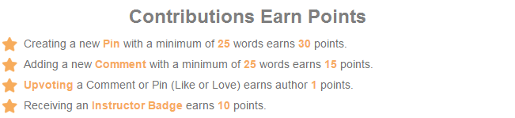

An Important Tip: Be careful when linking to sites or articles that require logins! Make sure to make use of the “Preview” feature to make sure YellowDig can display your Pin effectively. Articles from websites like the New York Times, Wall Street Journal, the Financial Times, etc., will require logins- submitting these traditionally may create a barrier for your classmates. Instead, you should make a PDF of the article you wish to share, which you can attach to your Pin.
How To Begin: Make a Pin!
- First, press the pin button at the top left.
- Then, copy and paste the link and an image and short summary of the article should appear.
- Write down your thoughts on the article (where appropriate add pictures, videos, or documents, and tag information) and press post.
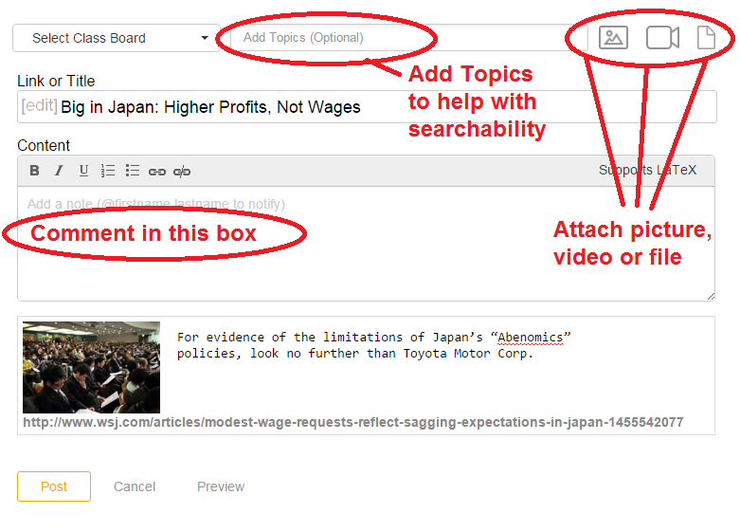
You can also tag people in your post by typing @theirname in your pin.
You may be using YellowDig in other courses. You will be able to cycle through your course “boards” using the dropdown at the top of the page:
YellowDig will send you e-mail notifications, based on your Notifications Settingss. Note: These are independent of your CANVAS Notifications Preferences.
You can adjust your YellowDig Notifications Preferences by first your name and dropdown menu from the upper-right:
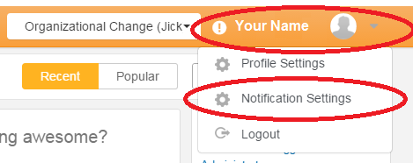
Then, choose the items when you want to get notified, and click UPDATE:
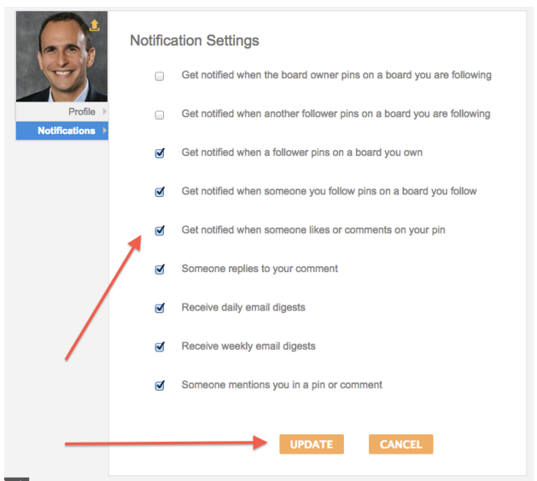

- If you encounter any issues you should contact the CBS Canvas Team at canvas@gsb.columbia.edu

