Updated March11th, 2021

MRKT8605, Succeeding in Consulting:
From Project Manager to CEO Advisor
Summer 2021

Session: Summer 2021

Time: Summer A Term beginning May 10: Mondays 3:50pm – 7:05pm

Room: Online

Instructors: Toos Daruvala
td2507@columbia.edu
917-626-3570

Joe Timko
jt2997@columbia.edu
973-214-7155
TA: TBD

Instructor Background

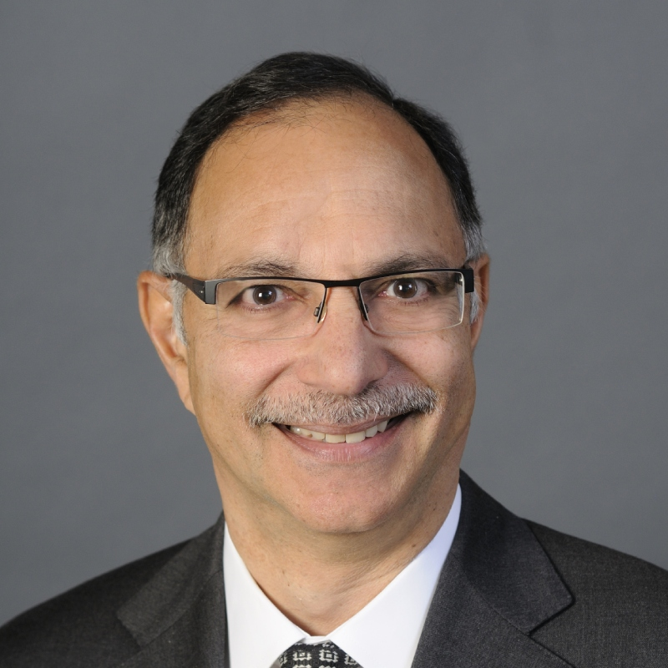
Toos Daruvala is a former Senior Partner at McKinsey and most recently served as co-CEO of MIO Partners, Inc (the in-house asset manager for McKinsey & Co). Toos retired from McKinsey in 2015, having joined in 1983 and being elected senior partner in 1995. Toos led the Americas Risk Management practice, the Americas Banking and Securities practice, and the buildout of McKinsey’s global Risk Advanced Analytics capability. Toos served on the global board of McKinsey (the Shareholders Council) and the Advisory board of the McKinsey Global Institute. Toos currently serves on the board of the Royal Bank of Canada (RY) and the New York Philharmonic; previously he served on the board of Card Connect (CCN), which was acquired by First Data Corporation. Toos serves on the Advisory Board of the Ross School of Business at the University of Michigan, Ann Arbor, and is Executive-in-Residence and Adjunct Professor at the Columbia Business School.

Joe Timko is a former McKinsey & Co partner, where he focused on industries such as communications equipment and services, IT software and services, industrial controls, and chemicals. In 2010, Joe moved to the corporate sector where he served as Chief Strategy Officer for two Fortune 500 companies (ADP, a leading human capital software and services company, and Pitney Bowes, a global player in shipping and communications). More recently, he spent 3 years in the strategy practice of Ernst & Young, where he was managing director in the Americas advisory strategy practice. Joe currently serves on the Board of PlanetiQ, a satellite weather data company, and Navicore Solutions, a consumer debt counseling non-profit. He previously served on the US Advisory Board of Enactus, a campus-based, entrepreneurial non-profit. He has been a regular guest lecturer at MBA schools including Columbia, UVa Darden, Duke Fuqua, UNC Kenan Flagler. Joe has been an Executive in Residence at Columbia for 5 years and is an Adjunct Professor.

Pre-requisites

This course is an advanced course tailored for students with prior experience in consulting or those who will be starting a career in management consulting after their MBA.

It is expected that students will take B8624-001/002 as a prerequisite, unless they have prior consulting experience. If they have not taken the prerequisite course, students can ask for an exemption by submitting the following exemption survey along with a resume: https://forms.gle/pxyepmRSEojD34F76

We ask that you use the form to request an exemption and not use email.

Please allow at least one week for a response, as your request may require deliberations among faculty.

Examples of some valid experiences to be exempted from taking B8624-001/002 as a prerequisite include experience in management consulting, such as pre-MBA consulting experience or MBA summer internship in a management consulting firm.

If you have any questions, please feel free to email the instructors.

Course Overview and Objectives

This course provides an advanced understanding of the evolving consulting industry and the skills and key learnings necessary to thrive at the levels of project manager through partner and senior partner.

Through a combination of lectures, class exercises, panel discussions, cases, and real-life examples drawn from the instructors’ combined 50+ years of consulting experience, this course focuses on:

- Reinforcing the problem solving and communications principles and skills taught in B8624-001/002
- Providing a perspective on where the management consulting industry is headed and what it means for the skills required of those entering it today
- Understanding the progression of skills, you will be expected to master at each rung of the consulting ladder as well as the trade-offs around leaving consulting at each career stage
- Developing 4 skills that are vital across multiple levels in a consulting career
  - Learning what it takes to develop people followership amongst junior consulting colleagues and to become a sought-after people developer within a consulting firm
  - Building domain expertise and intellectual capital for your firm
  - Accelerating the transition to personal counselor of senior clients by choosing who to invest in and building trust
  - Achieving commercial success and understanding firm and individual metrics and how they influence behaviors
- Learning how to drive a comprehensive change management program to move the client to action taking into consideration various components, such as governance, resourcing, obstacles, client motivations and politics, and communications.

The course´s ultimate objective is to position students for a successful run as a mid-level to senior-level consultant, with knowledge of how their skills will need to evolve, the subtleties of how to navigate their firms and client teams, and what it will take to thrive.

Connection with the Core

This course builds on knowledge from other courses primarily Strategy Formulation, Marketing Strategy and Lead: People, Teams, Organizations as well as the elective class Driving Strategic Impact: Mastering the Tools of Strategy Consulting.

Specifically, the class will integrate the fundamentals of strategy development, leadership, and consulting basics through multifaceted and real-life settings based on the experiences of the instructors.

Throughout the course, class exercises will also provide students the opportunity to integrate and further develop key consulting concepts like team management, influence, persuasion, and people development.

Grading

This course will use a combination of readings, case studies, lectures, class exercises and will require the completion of two group projects.

Requirements for the course and the contribution of each towards the final grade are as follows:

ACTIVITIES | PERCENTAGES
Attendance & participation | 20%
Pre-Class assignments & preparation | 20%
Case-Based Group Project #1, Due Class #3 | 25%
Case-Based Group Project #2, Due Class #6 | 35%

Attendance & Participation

Students are expected to attend all classes and have active involvement in the course.

This course adheres to Columbia Core Culture. Students are expected to be PRESENT, PREPARED and PARTICIPATE. Active participation in the class discussion is considered very important in this course.

Pre-class preparation of the cases and assigned readings is essential. All students have to be fully prepared to discuss cases during class (including the first class).

By making 20% of your grade dependent on your in-class participation we hope to encourage you to feel responsible for making this course work.
Class attendance and participation will be tracked. This course adheres to CBS Core Culture: If you miss 2 or more classes for unexcused reasons, you will at most receive a P1.
IMPORTANT NOTE: If you are planning to take the class but are waiting to be registered, it is important that you come to the first class to make sure you do not miss important material and your class participation grade is not affected.

Pre class assignments

There will be pre-class assignments for all of the classes. These pre-class assignments will consist of poll questions regarding students’ experiences and thoughts on particular issues as well as reflections on relevant articles or cases to be discussed in class. The pre-class assignments will count for 20% of final grade.

Group Projects

This course will have two major group projects. For the first group project, due in class #3, student groups will conduct a situation analysis, develop recommendations, and communicate them in a structured manner to their client. The first project will place emphasis on the fundamentals of problem solving and client communications. The second group project, due in class 6, will build off the recommendations in the first project. Student groups will present a comprehensive change management program, having grappled with the various components, such as governance, resourcing, obstacles, client motivations and politics, communications, regulatory and stakeholder management.

For both projects, each team will need to meet with one of the instructors and present their work prior to the due date. The purpose of these meetings is to simulate a typical consulting team – senior partner interaction. You need to take these meetings seriously as they will figure into your grade. Sign-up sheets will be on Canvas. Selected teams will present their findings and approaches in class. Project grades (25% and 35% respectively) will be based on a combination of the presentation to the instructor and the final product.

Assignments will be graded on content and format, originality, analytical strength, feasibility, logic and preparedness in the meeting.

Course Sessions

Session | Topic | Readings & Preparation
1a. Course structure and overview of consulting industry | Course overview and introduction  Structure of the Consulting Industry: Review consulting industry segmentation; compare and contrast leading firms’ strengths and weaknesses; describe strategies firms are following to grow; contrast firm cultures and values
1b. Key trends in consulting industry and firms’ response | Trends in Consulting Industry: Discuss forces that will shape consulting in the future; how client needs are changing and how consulting delivery models are adjusting; the rising importance of technology and analytics; how firms are responding and what it means for the skills you need and the teams you will have to manage.  Panel of Senior Consultants: Experts will discuss current state and future of consulting industry | Required: Consulting on the Cusp of Disruption  Required: The 4th Industrial Revolution Has Arrived, Krell
2a. Career progression & Personal Strategy | Succeeding as a Post-MBA Associate: Discuss learnings and skill development for the post-MBA associate role; what typically trips people up; pros and cons of leaving consulting after 2-3 years
2b. Career progression & Personal Strategy | Succeeding as a Project Leader: Discuss the BCG case; learnings and skill development for the project leader role; beyond the basics what are best practices and tips; how to best drive your consulting team's engagement; how best to drive the client team's cooperation and commitment to action; discuss exit pros and cons | Case: Developing Professionals – The BCG Way (A)  - For each of the four consultants, what are their strengths & weaknesses?  - What are the prospects for promotion?  - What should each be focused on?
2c. Case application | Set up Wells Fargo Case: Explain expectations for structuring problem and communicating analyses and recommendations for case discussion in Class 3
Session | Topic | Readings & Preparation
3a. Case application | Case Part 1 - Developing an Integrated Strategic Agenda: Working in teams, student will conduct a situation analysis, develop recommendations, and communicate them in a structured manner to their client; The case will place emphasis on the fundamentals of problem solving and client communications. | Case: Wells Fargo – setting the stagecoach thundering again  Your assessment of the situation and recommendations to the new CEO.
3b. Career progression & Personal Strategy | Succeeding as a Partner and Senior Partner: understanding what best and worst partners do; summarizing the critical skills needed to be a successful partner/ senior partner; understanding the differences in skills for partners and senior partners; what typically trips people up; exit considerations - what marketable skills you'll take with you from experiences at each level | Required: Leading Change, Kotter  Required: An overview of Intentional Change from a Complexity Perspective, Boyatzis
4a. Consulting Skills: People leadership & followership | Building Leverage through Followership: Discuss how to be a highly effective follower and how to engender followership in others; what will be your brand of followership and your brand of leadership; the importance of finding your go-to people so you can build your family tree; the tradeoff of giving people step-up opportunities while still bringing the best to the client; how to give valuable, insightful feedback | Required: In Praise of Followers, Kelly
4b. Consulting Skills: Domain expertise | Building Domain Expertise & Intellectual Capital: Discuss the requirement to build domain expertise; how to select a good domain to invest in; how large an effort it requires; what kind of activities will contribute to your expertise; how people who have gone before you built their domain expertise | Required: Outliers (Chapter 2), Gladwell  Required: The Great Practice Myth: Debunking the 10,000 hour rule, 6Seconds.org
5a. Consulting Skills: Personal counselor | Accelerating the Shift to Personal Counselor: The art and science of building trust-based relationships; how to choose who to invest in; the many ways to connect personally and build trust with clients; the right way to stay in touch; dealing with leadership turnover | Required: The Trusted Advisor (chapter 1, 2 and 3), Maister
Session | Topic | Readings & Preparation
5b. Consulting Skills: Commercial capabilities | Achieving Commercial Success: Understand firm economics and individual metrics and how they influence behaviors; tactics & ways to better engage with clients to generate valuable work; characteristics of successful relationships and how to enhance them
6. Case application | Case Part 2 - Getting to Action and Real Change: Returning to the earlier case, teams will refine their recommendations taking into account course learnings, and develop a comprehensive change program to implement their recommendations including: considerations of client dynamics, short term versus long term, the personal outcomes for the client executives involved, and other nuanced factors. Discuss wrap up and summary learnings from the course | Case: Wells Fargo – setting the stagecoach thundering again

Required Reading Materials

- Krell, Eric. The 4th Industrial Revolution Has Arrived, 2019. Consulting Magazine
- Christensen, Clayton M., Wang, Dina, van Bever, Eric. Consulting on the Cusp of Disruption, 2013. Harvard Business Review
- Kotter, John. Leading Change: Why Transformation Efforts Fail. 1995. Harvard Business Review
- Boyatzis, Richard. An overview of Intentional Change from a Complexity Perspective. Case Western Reserve University
- Kelly, Robert E. In Praise of Followers, 1988. Harvard Business Review
- Gladwell, Malcom. Outliers Little, Brown and Company. *Available via CLIO Columbia*
- 6Seconds.org. The Great Practice Myth: Debunking the 10,000 hour rule.
- Maister, David. The Trusted Advisor, 2001. Simon and Schuster.

Required reading materials can be found on Canvas and are to be used only for the academic purposes of this class. Students are not permitted to share materials with anyone outside the class.

Other recommended reading materials

- Rasiel, Ethan M. The McKinsey Way. 1999. McGraw-Hill
- Kiechel III, Walter. The Lords of Strategy: The Secret Intellectual History of the New Corporate World .2010. Harvard Business Press
- Minto, Barbara. The Pyramid Principle: Logic in Writing and Thinking. 1978. Pearson Education
- Bradford, Tessa, Schaninger, Bill. The Four Building Blocks of Change, April 2016. McKinsey Quarterly
- Tilcsik, Andras, Almandoz, Juan. When Expertise becomes a Liability. 2016. Rotman Management Magazine
- Jones, Barry, Silverstein, Michael. Opportunities for Action. 1997. Boston Consulting Group

Required Cases

- Nanda, Ashish, Morrell, Kelly. Developing Professionals – The BCG Way (A). 2006. Harvard Business School.
- Gujarathi, Mahendra R., Barua, Samir Kumar. 2017. Wells Fargo – setting the stagecoach thundering again. North American Case Research Association.

